ITEM ONE

SECTION A
1. Give one of the five senses of the body.
2. What special name is given to the young one of a rabbit?
3. State one use of proteins in the body.
4. In the space provided below, draw a well labeled diagram to show that air has weight.

5. Name one natural source of heat in the environment.
6. Why should sick people be given special care?
7. Of what importance is a lateral line to a fish?
8. Write any one common example of a communicable disease in our community.
9. Identify the structure that joins bones to muscles.
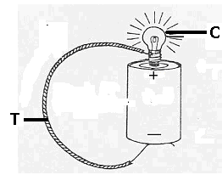The diagram below shows a simple circuit. Use it to answer questions 10 and 11.

10. Using arrows, show the direction of flow of the electric current along the wire marked T.
11. Apart from light, which other form of energy is produced at C?
12. Explain the term “magnetization”.
13. Why should you apply grease or oil in moving parts of a machine?
14. Of what importance is perspiration on the health of human beings?
The diagram below shows a glass of water with a straight ruler in it. Use it to answer question 15.
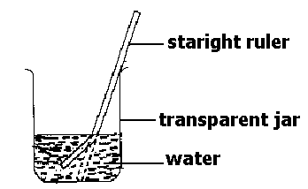

15. Why does the ruler in the jar above appear bent?
16. Identify any one structure which helps plants with weak stems to climb other plants.
17. Name any one ungulate mammal.
18. Mention one disease that affects both poultry and rabbits.
19. Write down any one energy resource from animals.
20. State any one way by which sound can be stored.
21. In which part of the body are lungs found?
22. Give any one characteristic of an image formed through a pin-hole-camera.
23. Which part of an insect has a similar function as of stomata on leaves of plants?
Study the diagram below and use it to answer the questions that follow.
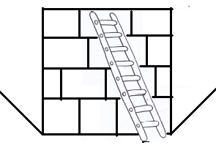

24. Identify the type of machine drawn above.
25. Give one example of a non-biodegradable waste material in our environment.
26. Write down one disease that affects both the muscles and the bones of the skeletal system.
27. What name is given to the arrangement of the seven colours that appear when a ray of light is refracted through a triangular prism?
28. Give one way methods used in the preservation of fish and millet differ.
29. Why is the handle of an flat iron box usually made of wood or plastic?
30. Identify any one disease that affects human kidneys.
31. Define the term vices in poultry rearing.
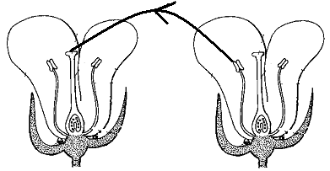 Study the diagram and answer the questions that follow.

32. Name the type of pollination shown in the diagram above.
33. Mention one measure used by the government of Uganda to fight against the spread of malaria.
34. Give one example of anti-social behaviour practised in your school.
35. State one way by which friction can be increased.
36. Why is it advisable for parents to keep drugs out of reach of children?
37. Francis planted a bean seed and after three days, it germinated. What type of change did the seed undergo?
38. Suggest one reason why animals move.
39. Mention one function of teeth in food digestion.
40. Which type of gas is contained in a fire extinguisher?

Section B
41(a) Give one example of each of the following:
(i) artificial source of light...............................
(ii) natural source of light..................................
(b) Why is the moon said to be non-luminous object?
(c) State one way in which reflection is useful to man.
42(a) Convert 77⁰F into the Centigrade scale.
(b) Give two ways a clinical thermometer is adapted to measuring human body temperature.
(c) Why doesn’t the scale of the clinical thermometer go beyond 39⁰C?
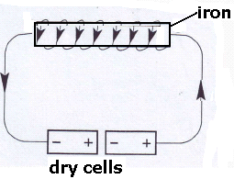43. The diagram below shows a method of making a magnet. Use it to answer the questions that follow.

(a) Name the method of making magnets shown in the diagram.
b) What would you do to the dry cells in order to increase the strength of the magnet?
(c) Apart from the method shown in the diagram, name any other two methods of making magnets.
44. Match the diseases with the germs that cause them.
Disease | Germ
typhus fever  elephantiasis  malaria  trachoma | Plasmodium protozoa  Bacterium chlamydia  Filarial worm  Bacterium ricketsia

(a) typhus fever....................
(b) elephantiasis................
(c) malaria..........................
(d) trachoma...............
45(a) Identify any two living components of the environment.
(b) Mention two ways people depend on each other.
46(a) Name the organ that removes urine from the body.
(b) To which body system does the body organ belong?
(c) Where is urine collected before it is removed from the body?
(d) Name one dangerous substance found in urine.
47(a) What is mulching?
(b) Give two advantages of mulching.
(c) How can mulching be dangerous to a farmer?
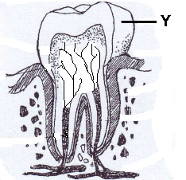48. The diagram below is of a human tooth. Use it to answer the questions that follow.

(a) Name part marked Y.
(b) State the function of the part marked Y on the diagram above.
(c) Mention one health problem that can affect human teeth.
(d) Suggest any one way you can care for human teeth.
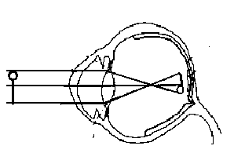49. Use the diagram to answer the questions that follow.

(a) What eye defect is illustrated in the diagram above?
(b) How can the eye defect above be corrected?
(c) Apart from the eye defect illustrated in the diagram, name two other eye defects.
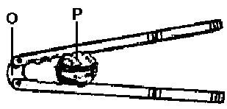50. The diagram below is of a simple machine. Use it to answer the questions that follow.

(a) Name the points of the machine marked O and P.
(b) To which class of levers does the machine belong?
(c) Using arrows, show the direction of the effort applied when the machine is being used.
51(a) Identify two common causes of sickness in a home.
(b) Write down two ways we can prevent sickness in a home without using drugs.
52(a) Write STD’s in full.
b) Suggest any two ways through which a P. 7 candidate can avoid contracting STD’s.
(c) Apart from having sexual intercourse with an infected person, give any other way of contracting HIV / AIDS.
53(a) Write AI in full as used in animal reproduction.
(b) Give one advantage of AI in animal reproduction.
(c) Define the following terms:
(i) gestation period
(ii) quarantine
54(a) Name any two ways plants can reproduce.
(b) Mention the method of propagation used in reproducing the following plants.
(i) bananas
(ii) sugarcane
55(a) What name is given to the smallest unit of matter that can exist alone with the basic properties?
(b) Give one state of matter.
(c) How does volume of a solid differ from its mass when subjected to different temperatures?
(d) Mention one change of state that takes place with heat loss.

END

ITEM TWO
SECTION A (40 marks)

1. Identify the group of vertebrate that feeds its young one on milk from mammary gland.
2. What is capacity?
3. Give one difference between plants and animals though they are all living things.
4. Write the component of soil that is formed from plant and animal remains.
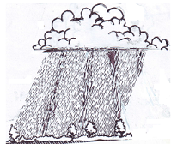The diagram below shows a type of weather in our environment. Use it to answer questions 5 and 6.

5. Which condition of weather is shown in above diagram?
6. How can you protect yourself from the danger of the above type of weather?
7. State the functional difference between arteries and veins.
8. Under what condition would you advise a poultry farmer to carry out culling?
9. Give one way through which pineapples are propagated.
10. Mention the property of air that helps a P.6 pupil drink soda from a bottle using a straw.
11. Apart from filtration, name one other method that is used to obtain clear water for washing.
In the diagram below, normal bean seeds were planted and the conditions shown in the experiment. Study the diagram and use it answer questions 12 and 13.
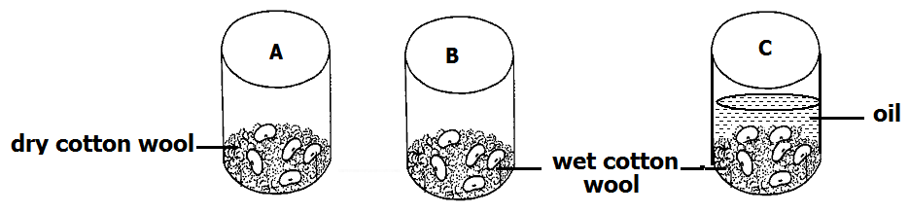

12. What condition is missing in container A?
13. State the role played by cooking oil in container C.
14. Define the term “addiction” as used in drugs use.
15. Name one vaccine that is administered orally.
16. Why is it important to carry out mulching in crop growing?
17. How is the soap useful when bathing?
18. Apart from rain and lakes, state any one natural source of water.
19. Give one plant that can be grouped together with Mosses.
20. What is soil conservation?
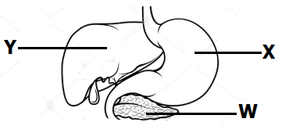The diagram below shows part of the digestive system. Use it to answer questions 21 and 22.

21. Name the part marked W.
22. Where is the digestive juice produced at part marked Y stored?
23. Which sense help you to identify the colour of a cloth?
24. Give one advantage of using paddock grazing in livestock management.
25. How often should one brush teeth?
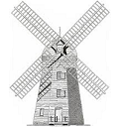The diagram below is of a device driven by one of the resources in our environment. Use it to answer questions 26 and 27.

26. Name the above device.
27. State the resource that enables the above device to work.
28 How is heat different from temperature?
29. Write down one activity of PHC that helps to promote community hygiene.
30. Give one malnutritional disease known to you.
31. What type of change occurs when water changes to ice?
32. Identify the product mainly got from Saanen goat.
33. Give one example of a person with special needs.
34. How is the reproduction of yeast different from that of other fungi?
35. In which body part does respiration take place?
36. What is pitch as used in the study of sound?
37. Why do we need latrines at school?
38. Write 3D’s in full.
39. State one characteristic of arachnids.
40. Mention the intestinal worm that is prevented through eating fully cooked beef or pork.

Section B
41(a) What are essential drugs?
(b) Give one example of essential drugs.
(c) Mention any one quality of an essential drug.
(d) How can essential drugs be a disadvantage to us?

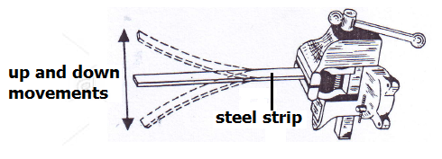42. The diagram shows the movements of a steel strip after being twanged. Use it to answer questions that follow.

(a) What term describes the up and down movement of the steel strip after being twanged?
(b) How does the sound produced by the steel strip be heard by Peter who is 10 metres away?
(c) Name one device that can be used to store the sound produce by the above ruler.
(d) How can the volume of the sound produced above be increased?
43. Below are the beaks and toes of birds. Use it to answer the questions that follow.
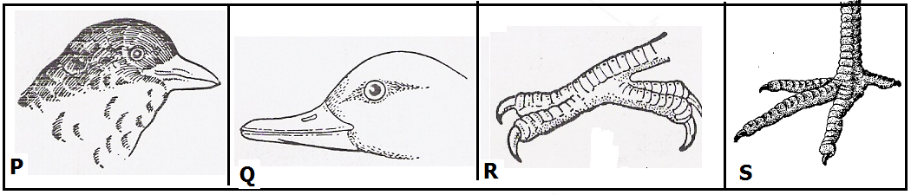

(a) In which environment does the bird with beak Q commonly found?
(b) What does the bird with foot marked P feed on?
(c) To which group of birds would you place the bird with beak marked R?
(d) Give the importance of toes in foot marked S to the birds that have them.
44(a) What is air?
(b) Mention any one component of air known to you.
(c) Which component of air supports the growth of bacteria?
(d) How can air be a danger in our community?
45(a). Mention the use of the following types of teeth in the human mouth.
(i) canine
(ii) incisor
(b) How are premolars adapted to their function?
(c) In which part of a tooth are the nerves and blood capillaries found?
46(a) In the space below, draw a leaf of a maize plant.

(b) Why is a maize plant regarded as an annual crop?
(c) How is a maize plant propagated?
(d) What is the difference between a maize plant and a fern?
47(a) Mention any one component of the circulatory system.
(b) Name the pigment in blood on which oxygen is carried.
(c) Why should blood from the heart be pumped to the lungs before circulation to other body parts?
(d) How can the circulatory system be cared for?
48(a) What first aid can you give for the following injuries?
(i) burn
(ii) near drowning
(b) Identify any one cause of convulsion.
(c) Give one way of preventing near drowning in our communities.
49(a) Mention one breed of cattle commonly kept for beef.
(b) What system of grazing cattle can one use when handling three cows in an urban place?
(c) Why is pasteurization a better method of preserving milk than sterization?
(d) Mention any one way of preventing viral diseases in cattle management.
50(a) What type of soil has the highest capillary?
(b) State one use of soil to man.
(c) How can you improve on the fertility of soil without applying artificial fertilizers?
(d) Give one danger of excessive application of artificial fertilizers.
51(a) By what process does heat travel through a vacuum?
(b) State any two effects of heat on matter.
(c) How is heat energy useful in our daily life?
52. The diagram below shows one of the system in the human body. Use it to answer questions that follow.
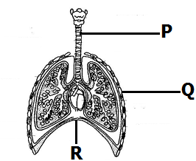

(a) Name the body system shown in the above diagram.
(b) Identify part marked Q.
(c) What happens to part R during breathing in?
(d) Why is part marked P made of rings of cartilage?
53(a) Which indicator of a dirty environment is detected by the nose?
(b) State the vector that is common in places with poor sanitation.
(c) How is the vector in (b) above a danger to human health?
(d) Give any one principle of PHC.
54. The diagram below shows a burning candle. Use it to answer the questions below.
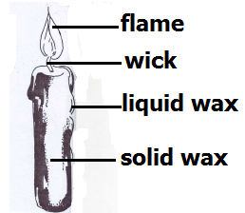

(a) Give the use of the flame above to man.
(b) What type of change in the environment occurs when:
(i) solid wax melts
(ii) the wick burns
(c) How is the use of candle wax a danger in the environment?
55(a) What is nutrition?
(b) Apart from carbohydrates, which other class of food provide the body with energy?
(c) Identify one food stuff that can provide the body with protein.
(d) Under what condition is one advise to take food rich in iodine?

END

ITEM THREE
SECTION A (40 marks)
(For questions 1-40, carry one mark each)
- Write AIDS in full.
- Give one disadvantage of friction in machines.
- Why is the changing of water into ice referred to as a physical change?
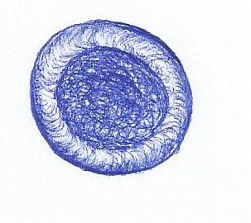
- State the importance of the blood cell whose shape is drawn below.

Mention one material you would need to prepare Oral Rehydration Solution.
- . Give one reason why farmers mulch their gardens.
- State any one way farmers in Uganda control external cattle parasites.
- How is the habit of bees visiting flowers important to plants?
- How does refrigeration prevent food stuffs from going bad?
- Why does a fish die when removed from water?

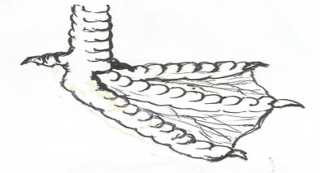
Use the diagram below to answer questions 11 and 12.

M

- Identify the type of birds with such a type of foot.
- How do birds with such type of foot make use of the structure labelled M?
- State any one law that governs the taking of alcohol in Uganda.
- Mention one animal that uses echoes in its movement.
- What is the role of sunlight during photosynthesis?
- State one reason why you would prefer artificial insemination to natural insemination in cattle keeping?
- Identify one health habit that may result into destruction of the human lungs.
- Give any one example of a non-renewable resource in the environment.
- What do we call the method of obtaining clean water from muddy water illustrated below?
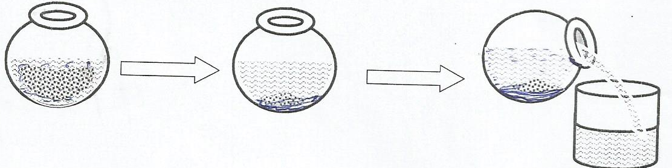

- Give one reason why the clean water obtained by the method in No. 19 above is not safe for drinking.
- Mention one health problem that may result from over excitement or prolonged hunger.
- What is the use of a vent pipe found on a VIP latrine?
- Identify any one sex offence faced by adolescents.
- In one way, give advice to Mrs. Kafeero so as to control the vice of egg eating on her poultry farm.
- Identify one danger that may result from sharing a house with potted plants at night.
- State one factor that adapts a housefly to spreading germs.
- What form of energy would you employ to make water evaporate?
- In one way, state how you would help your young sister to promote personal hygiene.
- State the reason why a cockroach moves with its abdomen raised on a floor with maize flour.
- Why are electricity wires fixed loosely on poles?
- Besides using a child health card, how else can you identify a child who was immunised against tuberculosis?
- Names one pest that attacks root crops.
- State a health problem children may face if underfed with food rich in carbohydrates.
- Calculate the density of an object whose mass is 100g and volume 200cc.

Use the diagram below to answer the questions 35 and 36.
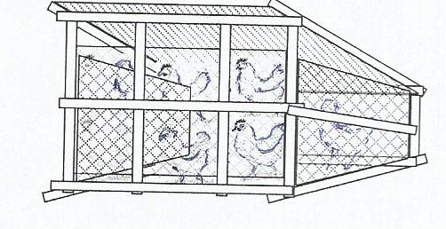

- Identify the system of poultry keeping illustrated above.
- Give one advantage of the poultry keeping system illustrated above.
- Explain one way how blood is prevented from flowing back along vessels during circulation in the human body.
- Besides banana fibres, give one example of a plant fibre.
- Name the amphibian that lays the eggs drawn below.
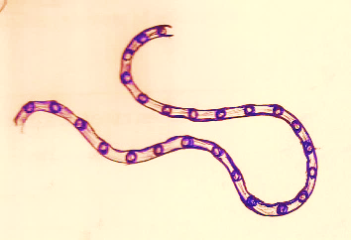

- Suggest one way of preventing ourselves from tape worm infections.

SECTION B (60 marks)
(For questions 41 – 55 carry four marks each)
- a) What is soil erosion?
b) Write down one agent of soil erosion.
c) Identify any two dangers of soil erosion.
- a) Name the type of metamorphosis a housefly undergoes.
b) How is a housefly useful during its larva stage?
c) Identify any one disease spread by houseflies.
d) Suggest any one way of reducing the spread of diseases by houseflies.

- The diagram below a process in nature. Use it to answer the given questions.
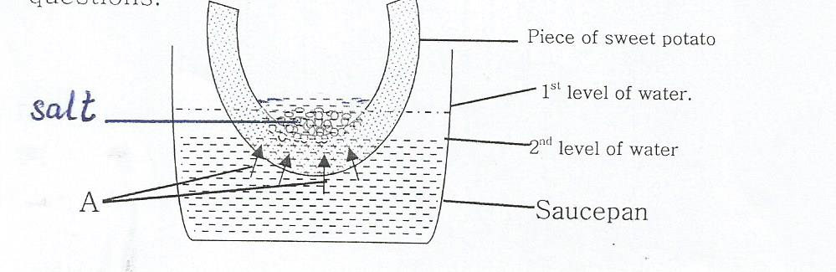

- Which process in nature is represented above?
- What do arrows marked A represent?
- Why did the water level in the saucepan reduce after sometime?
d) How is the above process useful to plants?
- State one activity a family may do to promote;
- Family sanitation:
- Immunisation:
- Food and Nutrition:
- Control of communicable diseases.
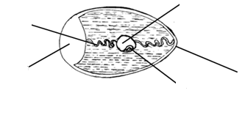
- The diagram below is of a cross- section of an egg. Use it to answer the given questions.
B
D
E
C
A

- Name the parts labelled C and A.
- Apart from protecting the inner parts, give one other function of part D.
c) Which letter indicates the part that develops into a chick?
a) What is environmental degradation?
- Outline any two human activities that lead to environmental degradation.
c) Identify one way by which man helps to allow continued existence of trees.
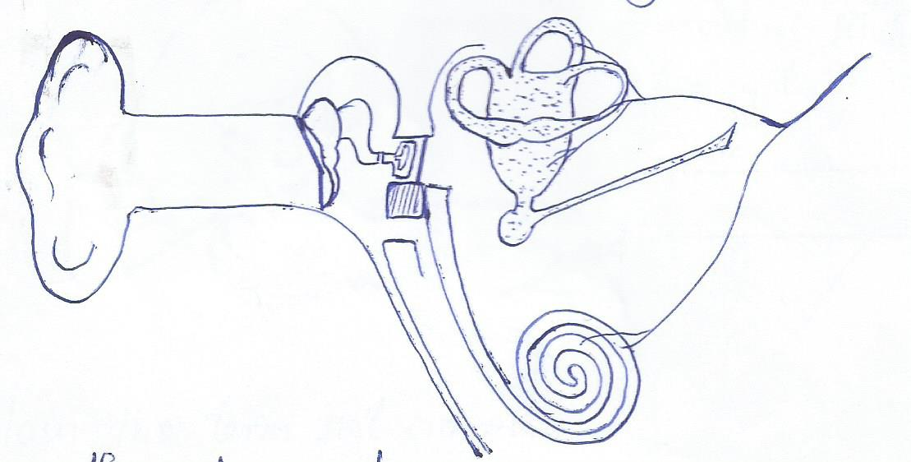
- The diagram below is of a human organ. Use it to answer the given questions.
M
Ossicles

N
O

a) Name the part labelled M.
b) Give the role of the parts marked O during the hearing process.
- Which letter represents the part that equalises the pressure in the ear to the
atmospheric pressure?
d) State one major function of the organ in the diagram.
- a) Mention any two advantages of a VIP latrine?
b) Suggest any one way of preventing convectional pit latrines from smelling
badly.
- Give the reason why a pit latrine should be located at least 30m away from a water source.
- a) In one sentence, describe the first aid you would give a victim of;

- a burn:
- fever:
- near drowning:
- Why should a person who has taken paraffin or jik not be made to vomit?

- Use the diagram of the thermos flask below to answer the given questions.
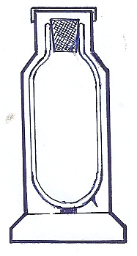
D

E
F
s

- Name the part marked D
- Give the functions of the parts marked F and S.
- Explain how the parts marked E control heat loss or gain when the equipment is being used.
- a) Identify any two problems faced by girls who become pregnant at a tender
age.
b) Identify any two categories of people in our society who stand high risks of catching HIV.

- The diagram below shows a method of producing alcohol. Use if to answer the given questions.
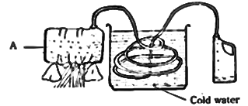

a) Name the method of producing alcohol in the diagram.
b) State the role of cold water in the process above.
c) Mention the form of physical change that takes place in drum A.
- Give one use of the alcohol produced by the above method.
- a) State two factors you would use to identify a dicotyledonous plant.
b) Give the role of each factor below during seed germination.
i) Moisture:
ii) Oxygen:
- Match the processes to the gases they need to take place.
Process Gas
- Preservation of bottled drinks: carbon dioxide
- Rusting nitrogen
- Storage of semen carbon dioxide
- Putting out fire oxygen

- Preservation of bottled drinks:
- Rusting:
- Storage of semen:
- Putting out fire:

- Use the reproductive system below to answer the given questions.
U
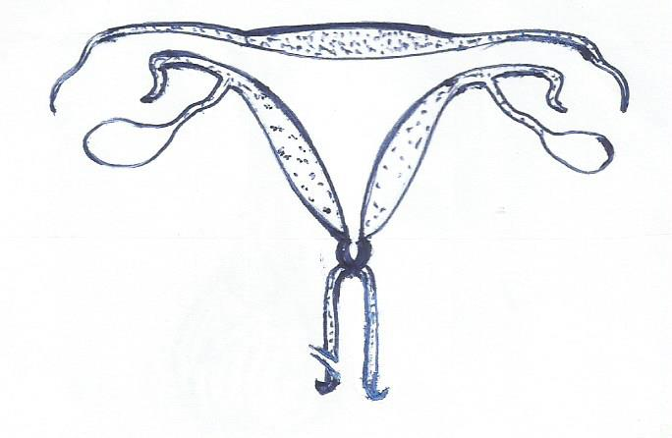

Q

P
T R
S

- Name the part marked P.
- What do we call the type of pregnancy where a zygote implants itself in part
Q?
- What health problem affects part R that women should always check for?
- Which letter indicates the part where sperms are deposited during sexual intercourse?

END

ITEM FOUR
SECTION A:
1. Which body organ is used for tasting?
2. What does the term “vice” mean in poultry keeping?
3. How is a seed different from a fruit?
4. Why are metals painted?
5. Mention one characteristic which makes a spider not to be grouped under insects.
6. Why do people preserve food?
7. How are conifers different from other non-flowering plants?
8. What property of air does the diagram illustrate?
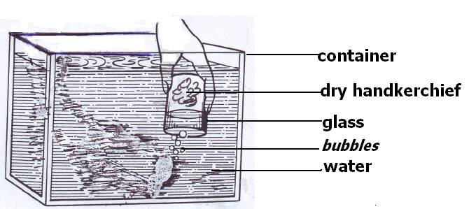

9. Give the function of a pinna in a human ear.
10. Explain how plants are used as energy resources in our environment.
11. Name the type of change that takes place when mangoes ripen.
12. Why does a needle placed gently on the surface of water float?
13. What is the importance transpiration to plants?
14. What component of loam soil makes it most suitable for growing crops?
15. State the importance of grit in the digestive system of a bird.
16. Identify one example of a magnetic substance.
17. Smoking is very bad to human health. Why does the government of Uganda licence companies that make cigarettes?
18. Write CDD in full.
19. Why are people encouraged to drink boiled water?
20. A female fish lays eggs in water. How are these eggs fertilized?
21. Nanku burnt herself with a hot flat iron. What type of injury did she get?
Use the diagram below to answer question 22.
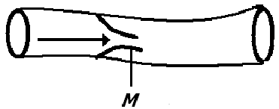

22. What is the importance of the structure marked M in the above blood vessel?
23. Give one difference between a sprain and a strain.
24. In which part of a human body are red blood cells made?
25. Identify the body part an insect uses for balancing during flight.
26. What does the term “resource” mean?
27. Why do we see the flash of lightning before we hear the sound of thunder during rain storms?
28. Write down the vector that spreads elephantiasis.
29. Convert 100⁰C to ⁰F.

30. What eye defect is shown in the diagram below?

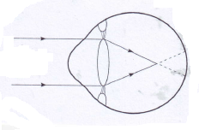

31. Why is the measles vaccine administered at the age of nine months?
32. State one advantage of family planning.
33. Identify one psychological characteristic which is common in adolescents.
34. Apart from getting sunlight, why else do weak stems climb others
35. How does rural electrification help in conserving the environment?
36. Name one cold blooded vertebrate that has a bony shell.
37. Identify one health reason why building industries should be limited.
38. Why should wood being burnt into charcoal be covered with soil?
39. In the space provided below, draw a compound pinnate leaf.

40. Why is food digestion said to begin in the mouth?
SECTION B
41. (a) What is a solute?.
(b) Give one solute used in making ORS.
(c) Why is water said to be a universal solvent?
(d) What health condition can be treated using ORS?
42. The diagram below shows an electric circuit. Study it carefully and answer the questions about it.
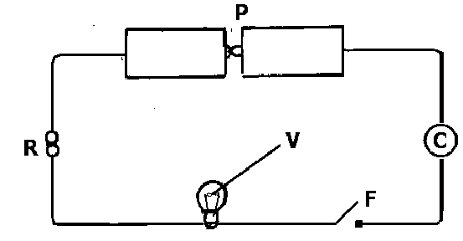

(a) Name part marked F.
(b) Give the function of part marked R.
(c) What form of energy is contained in part marked P?
(d) Why should part marked V fail to produce light when F is closed?
43. Study the diagram and answer the questions about it.
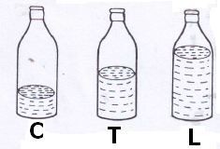

(a) Which of the bottles, when air is blown into them, will produce sound of the highest pitch?
(b) Give a reason for your answer in (a) above.
(c) How can you make the bottles to produce the same sound pitch of sound?
(d) What does the term “volume of sound” mean?
44(a) Give one example of a legume.
(b) How are nitrates important to leguminous plants?
(c) What food value do we get from leguminous plants?
(d) Apart from root nodules, given any other characteristic of leguminous plants.
______________________________________________________________________
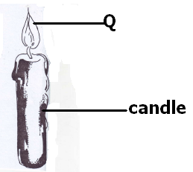45. The diagram shows a burning candle. Use it to answer the questions about it.

(a) Name two forms of energy given off at Q.
(b) Which component of air supports the candle to burn?
(c) Identify one other process in living things that uses the same gas as in the experiment above.
46(a) Identify one type of cattle kept in Uganda.
(b) Give the importance of the type of cattle you have named in (a) above.
(c) Identify two advantages of rearing exotic breeds of cattle over local breeds of cattle.
47(a) Define the following terms:
(i) Temperature
(ii) boiling point
(iii) heat
(iv) evaporation
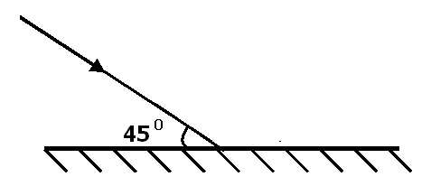48. The diagram below shows a light ray being reflected through a plane mirror.

(a) Complete the diagram above.
(b) Calculate the value of the angle of reflection.
(c) What type of reflection is shown in the diagram?
(d) Give one characteristic of images formed through a plane mirror.
49(a) What is Primary Health Care?
(b) Give two elements of Primary Health Care.
(c) State one activity done by a community in order to promote primary Health Care.
50(a) Write AIDS in full.
(b) Write down two ways through which AIDS is spread.
(c) What is the best way for a P. 7 pupil to avoid contracting AIDS?
51. Study the diagram below and answer the questions about
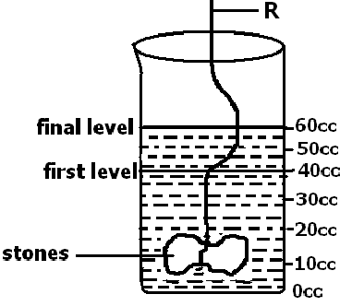

(a) Find the volume of the stone.

(b) Give the use of the use of R in the experiment.
(c) Why do objects weigh less in water than in air?
(d) Name the method used to find the volume of the stone.

52. Study the diagram of the kidney and answer the questions that follow.
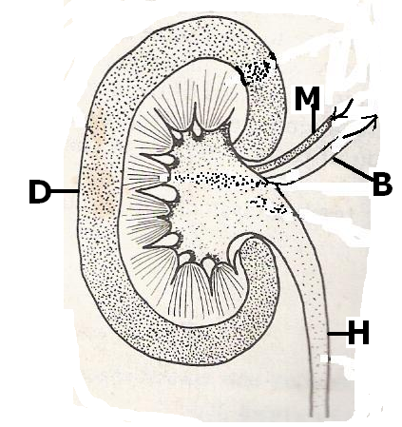

(a) Name the parts marked H and D.
(b) Which type of blood is carried by blood vessel marked B?
(c) Give one disease that affects the organ in the diagram above.
53(a) What is a food chain?
b) Differentiate between primary consumers and secondary consumers.
(c) Give two ways how plants depend on each other.
54. The diagram below shows a clinical thermometer.
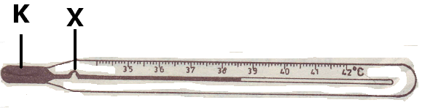

(a) What is the use of the above instrument?
(b) Name liquid marked K.
(c) In a human heart, which part carries out a similar function as part marked X?
(d) Give the importance of part marked X.
55. Study the diagram below and answer the questions that follow.
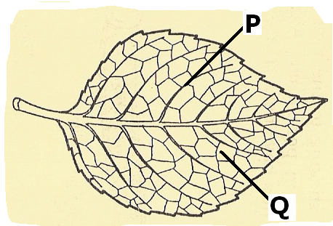

(a) Name part marked P
(b) What important process takes place in part marked Q?
(c) Give two raw materials needed for the process named in (b) above to take place.

END

ITEM FIVE
SECTION A:
1. Name the human organ for tasting.
2. Why is brushing teeth a good health practice?
3. Write down one activity a farmer can do in the dry season.
4. How does bush burning cause soil erosion?
5. State any one danger of defecating in the bush.
6. In one sentence, state how heat promotes food hygiene.
7. Give any activity done to protect cattle from ecto parasites.
8. How is the function of a fuse similar to a switch in an electric circuit?
9. In one word, write the name given to animals without backbones.
The diagram below is of a simple machine. Use it to answer questions 10 and 11.
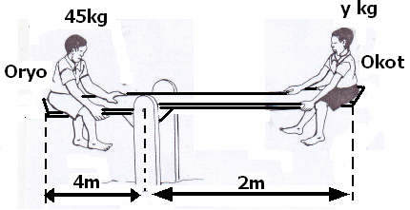

- Use letter “F” to show the position of the fulcrum.
- Which class of levers is the above machine?

12. In what way is a human kidney and the skin similar in function?
13. Why is soil erosion considered as a physical change?
14. Name the type of digestion in which the teeth breaks down food into small particles.
15. How do plants reduce the amount of carbon dioxide in the atmosphere?
16. Give the type of electricity produced when a plastic pen is rubbed on the hair.
17. In one sentence, write down the difference between lung cancer and other respiratory diseases.
18. How do germs that cause AIDS affect the immune system of the body?
19. Name the part of a flower which attracts pollinators.
The diagram below is of a joint on a human arm. Use it to answer question 20.
- 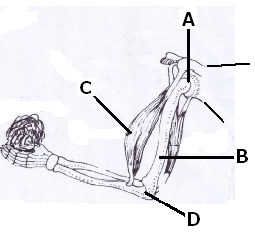Why is the joint A able to turn in all directions?
- What type of energy is possessed by a radio placed in a moving car?

22. Why does class soil retain water longer than sandy soil?
23. In the space below, draw and label prop roots.

24. How can a farmer make use of cow dung to control deforestation?
25. Name the non-living resource which supports life of a tilapia.
26. Why should garden tools be cleaned every after use?
27. Name the part of the body where respiration takes place.
28. Mention one way a magnet can lose its magnetism.
29. Why do motorcyclists wear helmets?
30. Name any one plant that stores its food in the stem.
31. Give one factor that determines the size of an image in a pin hole camera.
32. Which component of air is a bi-product of photosynthesis?
The diagram below is of a simple complete electric circuit. Use it to answer question 33.
- 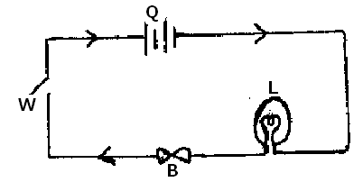Name the form of energy which takes place at point L when the circuit is completed.
- Which health measures can be done to a latrine which smells and is full of flies?

35. Give one way in which fruits are good in prevention of deficiency disease.
36. When it is said that Isaac is anaemic. What mineral is he lacking in his blood?
37. How can the School Health Committee tell whether a child is already immunized against measles without referring to the Child-Health Card?
38. Mention one danger of sharing a drug with another patient.
39. Apart from controlling erosion, give one other reason why mulching is important.
40. Name the major way through which AIDS virus is spread.

SECTION B
41a). Name the vaccine used to immunize against tuberculosis.
b). Give the immunization site for whooping cough.
c). Why is immunization an important health activity among children?
d). Apart from immunization, state any other way children’s immunity is boosted.
42. The list below shows two groups of vertebrates shown above.
A B
Chameleon toads
Lizard frog
Snake newt
Crocodile salamander

a). Identify the groups of vertebrates shown above.
- A _______
- B _________
b). How is reproduction of animals in group A different from those in group B?
c). State any one use of scale on a fish.
43a). Give the meaning of the following words as used in the study of sound.
- pitch ________________
- frequency ____________
- volume __________
b). How does a guitar produce sound?
44a). How do organisms such as mushrooms reproduce?
b). Give one similarity between a bacteria and fungi.
c). Give two examples of fungi apart from mushrooms.
45a). Give any two methods of making alcohol.
b). State any one scientific value of alcohol in the society.
c). Give any one health effect of alcohol to an individual.
46. The diagram below shows an object Y placed in front of a plane mirror M. Use it to answer the questions that follow.
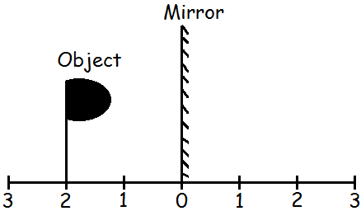

(a) Draw on the diagram above the image of the object P.
(b) Give any two characteristics of images formed in such mirrors mentioned above.
(c) State any one use of side mirrors to motorists.
47a). Give any one other state of matter apart from liquid.
b). Give two reasons why we give first aid to casualties.
c). How is a burn different from a scald?
d). Give one major cause of fainting.
48. The table below is about nutrition. Use it to answer question 48.
FOOD VALUE | SOURCE | DEFICIENCY DISEASE
_________________________ | fish | kwashiorkor
Vitamin A | Green vegetables | _____________________
Carbohydrates | ________________________ | Marasmus
__________________________ | Oranges, guavas | Scurvy

49. The diagram below is of a female reproductive organ in man. Use it to answer questions.
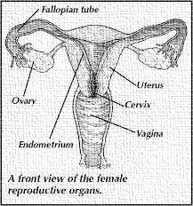

a). Name the parts labelled;
i. X _______ ii. Y ______
b). Give the function of part labelled X.
c). Name the part shown above where fertilisation takes place.

50a). Give any two disease vectors whose life cycle passes through water.
b). State nay diseases caused by poor sanitation in an area.
51. (a) Lightning can destroy buildings, give any other two dangers of lightening.
(b) Give any other two ways in which people can protect themselves from dangers of lighting.
52a). Which germ causes AIDS?
b). Why is abstinence considered the best method for controlling AIDS among youth?
c). Apart from AIDS, give two other sexually transmitted diseases.
53a). Name the type of blood found in the following blood vessels.
- vena cava ________
- pulmonary vein
b). How are valves useful in a human heart?
c). Name the component of blood that carries oxygen around the body.
54. Give the use of the following instruments as a weather station.
a). Anemometer __
b). Rain gauge ___
c). Wind sock ____
d). Hygrometer __________
55a). Mention any two agents of seed dispersal.
b). How is dispersal of seeds important?
c). How are fruits such as passion fruits adapted to the way in which they are dispersed?

END

ITEM SIX

SECTION A:
1. Which body part of a cow is attacked by a disease detected by using a strip cup?
2. Name the organisms found in root nodules.
3. What type of germination do cereals undergo?
4. Give one use of trees around a home.
5. Calculate the effort needed to raise a load of 25Kg. using the machine shown below.
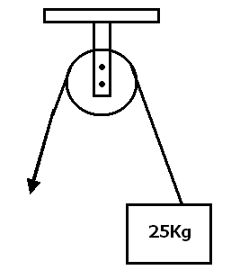

6. Calculate the electrical force produced by 4 ordinary dry cells.
7. Give the importance of webbed feet to a duck.
8. What is obtained by mixing a solvent with a solute?
9. Name the organ which controls the central nervous system.
10. What condition leads to goiter?
11. What is common about the blood carried by the venacava and the pulmonary vein?
12. How are seeds of a blackjack dispersed?
13. How do ferns differ from mushrooms?
14. What is the function of saliva in food digestion?
15. State the use of a fuse in an electric circuit.
16. How is heat transfer by radiation different from heat transfer by conduction?
17. Where in the body of a mammal does conception take place?
18. Why are roughages important in food digestion?
19. State one effect of motor accidents on people’s health.
20. How does overgrazing lead to soil erosion?
21. Write HIV in full.
22. Why is a vulture an important bird in the environment?
23. Apart from lungs and kidneys, name one other excretory organ of a human body.
24. What is the importance of chlorophyll during photosynthesis?
25. Which disease is characterized by loss of feeling in the body?
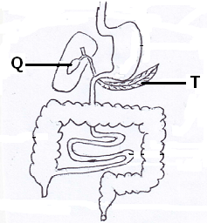 Use the diagram below to answer questions 26 and 27.

26. What is the function of the liquid stored in part marked Q?
27. Name the digestive juice produced by part T.
28. What causes fainting?
29. Give one reason why water is used in preparing oral rehydration solution.
30. Why is immunization in Uganda given to children freely?
31. Why is water not a good material in extinguishing petrol fires?
32. State one way of avoiding hookworm infection.
33. What change does salt undergo when it dissolves in water?
34. State the primary sex characteristic that takes place only in male adolescents.
Use the diagram below answer questions 35 and 36.
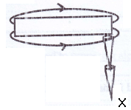

35. What method of magnetization is illustrated above?
36. What pole will X be?
37. At what stage of growth is a frog similar to a fish in terns of breathing?
38. What do you understand by the term arson?
39. Explain how a shadow is formed.
40. Name one pest that destroys maize plants.

Section B
41. Use the diagram below to answer the questions that follow.
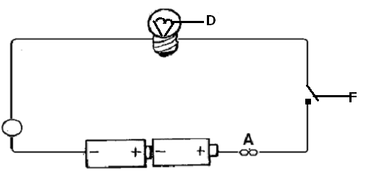

(a) What is the function of the following in the electric circuit?
(i) part A:
(ii) Part F:
(b) Name the mineral from which part D is made.
(c) Give the energy change that takes place at D when the circuit is closed.
42(a) Name two diseases immunized against at birth.
(b) State one use of a child health child to mothers.
(c) State one reason why measles is immunized against at the age of 9 months.
43(a) Give one reason why people take alcohol.
(b) Give one method used in preparing alcohol.
(c) State one body organ affected by excess taking of alcohol.
(d) Mention one danger of alcoholism to a family.
44(a) What is a balanced diet?
(b) What class of food is best for growth and repair of worn out parts of the body?
(c) What is the best food for babies?
(d) State one reason why bottle-feeding is highly discouraged.
45. The diagram below a brick being lowered in a cylinder containing water.
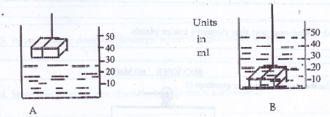

(a) What is the volume of the brick?
(b) If the mass of the brick is 60g, calculate its density.
(c) Why does the brick sink in water?
(d) Why do objects weigh less in water than in the air?
46(a) What is an alloy?
(b) What alloy is obtained by mixing copper and tin?
(c) Name one liquid metal.
(d) State one effect of heat on metal.
47. The diagram below is of a human heart. Use it to answer the questions that follow.
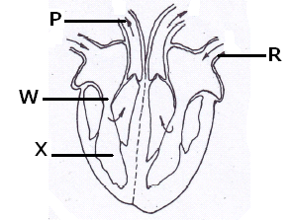

(a) Name part marked X.
(b) What is the function of part marked W?
(c) To which body organ does part marked P transports blood?
(d) Which type of blood is transported through blood vessel marked R?
48(a) What is the importance of oxygen in respiration?
(b) Mention two by-products from respiration.
(c) Mention one danger of having too much carbon dioxide in the body.

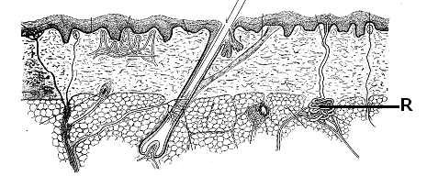49. The diagram below is of a human skin. Use it to answer the questions that follow.

(a) To which body system does the organ in the diagram belong?
(b) Name part marked R.
(c) Mention any one function of the organ shown in the diagram.
(d) Give one way of keeping the organ in a healthy and good condition.
50(a) What is an invertebrate?
(b) To which group of invertebrates do insects belong?
(c) How does a snail protect itself from enemies?
(d) What type of skeleton do insects have?
51(a) State two ways how man destroys the environment.
(b) State two ways of protecting the environment.
52. Complete the table below correctly.
DISEASE | CAUSE | MODE OF TRANSMISSION
Trachoma | ……………………………. | housefly
Sleeping sickness | Trypasoma | …………………………………..
………………………………….. | plasmodia | Female anopheles mosquito
Rabies | virus | ……………………………………

53 State the use of the following instruments.
(a) an anemometer
(b) hygrometer
(c) barometer
(d) hydrometer
54. What do we call each of the following operations?
(a) removing some crops from an overcrowded field.
(b) collecting semen from a selected bull and injecting it into the body of a female.
(c) separating productive animals from unproductive ones.
(d) giving liquid medicine to an animal using a gun.
55(a) Why do the joints in the skull not require synovial fluid?
(b) Why are people not immunized against HIV?
(c) Why cant people see around corners?
(d) Why do plants not make food at night?

END

ITEM SEVEN

SECTION A:
1. Write any one source of light that uses paraffin as fuel.
2. Why would you group a duck and a goose in the same group of birds?
3. in the space provided below, draw molecules as they appear in solids.

4. Which component of the environment is a habitat for fish and frogs?
5. State the function on root tubers to a cassava plant.
6. Draw and show the effect of heat on the water in the open container.
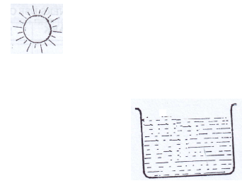

7. Identify one example of a group of simple machines.
8. Which of these two body organs is used for breathing: a nose, lungs?
9. Suggest any one activity a person could do to keep good health of the alimentary organs.
10. Mention any one thing we use to clean hair.
11. In which way is cockroach similar to a housefly as vectors?
12. Suggest any one thing local leaders could do to reduce on road accidents on busy roads.
13. Suggest one activity carried out to save a person who has taken rat poison.
14. State any one danger of living in a room with an active smoker.
15. Mention the cattle parasite that spreads East Coast Fever.
16. Write the element of PHC practised when a person feeds on a balanced diet.
17. Name any one member of a family who could properly teach babies between 2 – 4 years of age.
18. How do we care for our bones in the body?
19. Which gametes in the human reproductive system work in the same way as pollen grains in a flower?
20. Identify the form of energy a dry cell contains when it has just been manufactured.
21. Give a reason why plants are renewable resources.
22. Mention any common pest of banana crops.
23. What first aid would you give to a fainted casualty?
24. Name one disease of the digestive system.
25. Write the similarity in function between part marked R on the diagram of an insect with the human lungs.
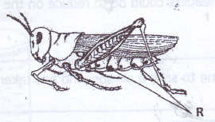

26. How would you protect a house in a home against strong winds?
27. Write any one activity a person does to control the spread of trachoma.
28. In one sentence give one activity carried out to improve on soil fertility.
29. List one social problem that affects the health of adolescents.
30. Define the word “food path”.
31. Mention the name of the thigh bone.
32. How do first class levers make work easy?
33. Mass is the amount of matter in an object. Give the standard units used in measuring Mass.
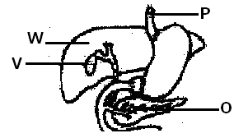 The diagram shows part of the digestive system. Study it and answer question 34.

34. Outline the use of part marked O during food digestion.
35. Where in the respiratory system is air moistened warmed before it goes to the lungs?
36. Apart from death, identify any other effect caused by road accidents on a person.
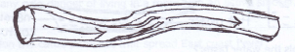
37. Name the part of the circulatory system shown in the diagram below.

38. Identify the lens that can be used to correct short sightedness.
39. How does the electrical method differ from stroking method while making a magnet?
40. State one activity done by a poultry farmer to control vices among birds.

Section B
41(a) Name the opposing force that works between to moving surfaces.
(b) Write two forms o0f energy produced by the force named in (a) above.
(ii) one poultry disease
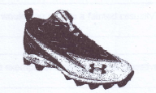
(c) By use of an arrow, indicate the structures on the sports shoes that increase friction as s person putting on the shoes is walking.

42. The diagram below shows two cooling containers. Container A is a plastic and container B is metallic.
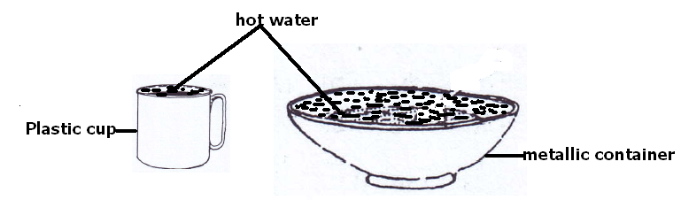

(a) Which container cools the water faster?
(b) Give a reason to support your answer in (a) above.
(c) Identify the process that enables water to cool down.
(d) Name any natural change where the process name in (c) above takes place.
43(a) What os personal hygiene?
(b) Write two activities a person carries out to keep clothes clean.
(c) Suggest any one danger of not keeping clothes clean.
44. Match the following items correctly.
PART FOOD DIGESTED
Mouth milk sugars
Duodenum cooked starch
Stomach fats
lactose proteins

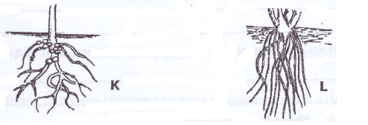45. The diagram below shows two root systems. Study them carefully and answer the following questions.

(a) Identify the root systems labelled with letters K and L.
(b) Write two uses of roots to plants.
46(a) Give two domestic appliances that use both electricity and magnets.
The diagram below shows a simple electric circuit. Use it to answer the questions that follow.

(b) Name part marked B.
(c) What is the voltage in the simple electric circuit shown above?
47(a) Define the term skeleton.
(b) Write any two functions of a human skeleton.
(c) In which is a skeleton in a goat different from that of a bee?
48(a) Write any three types of chicken reared in Uganda.
(b) List any one product obtained from poltry.
49(a) What name is given to the diseases we due to poor feeding?
(b) Give two examples of such diseases as mentioned in (a) above.
(c) Suggest one way of preventing such diseases.
50(a) List any two common types of changes in the environment.
(b) To which type of change does rusting belong?
(c) What piece of advice would you give to people to control rusting in metallic tools?
51(a) Mention any one example of energy resources.
(b) Why is the item you have given in (a) above called an energy resource?
(c) Mention one form of energy obtained from the above energy resource.
(d) Suggest the best way of handling energy resources that are non-renewable.
52(a) Give any two examples of diseases spread by mosquitoes.
(b) Mention the cause of one of the diseases you have named in (a) above.
(c) How ould you control the spread of such diseases without polluting the environment?
53(a) Identify the sounds made by the following animals:
(i) duck______
(ii) dog__________
(b) Give one device used to produce sound.
(c) Give one example of a local stringed instrument.
54(a) List two body organs which work together to make proper circulation of blood and oxygen in the body.
(b) Give the role of each of the organs you have named in (a) above in blood circulation:
55(a) Identify any two requirements for starting a livestock farm.
(b) Give any two advantages of keeping records on a farm.

END

ITEM EIGHT

SECTION A:
1. Name the body organ that detects the smell of good food.
2. Why is it dangerous to touch uninsulated electric wires?
3. Apart from discs and memory cards, name other device that can be used to store sound.
4. Identify one activity of man that leads to misuse of wetlands.
5. Of what use is a crop in the digestive process of birds?
6. What force is used to sharpen tools?
7. What property of magnetism is illustrated below?
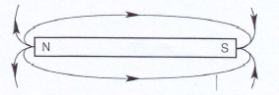

8. Oxygen is one of the components of air. How can it a danger to man?
9. How is the process of decomposition (decay) useful to farmers?
10. Mention one item used in keeping the human body clean.
11. Why is a blanket able to keep a person warm at night?
12. How does polio affect the skeletal system?
13. Mention one factor that leads to food poisoning.
14. Mosses are plants and mushrooms are fungi. How are mosses and mushrooms similar?
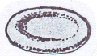15. State the use of the blood cells shown in the diagram below.

16. State the method used to find the volume of a papaw.
17. Write down one exotic beef breed of cattle.
18. Give one importance of a child health card to parents.
19. In which way are regular physical exercises important to the body?
20. State the element of PHC that controls population growth.
21. Which pest can be controlled using traps?
22. Give one health need of a pregnant woman.
23. Why should every family have enough food?
24. What makes the skin a storage organ?
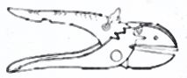
25. Mention the activity farmers carry out using the tool below.

26. Give the vector that breeds in rubbish heaps.
27. State the danger of sharing drugs meant for one patient.
28. Write one living component of the environment.
29. State one health benefit of cooking food.
30. Apart from filtration, identify one other way of making dirty water clean.
31. Which sexually transmitted disease affects eyes?
32. What happens when light rays meet a transparent material?
33. Where does re-absorption of useful materials take place in the kidney?
34. How is a sperm cell in human beings similar to pollen grains in plants?
35. Give one advantage of the paddock system in cattle keeping.
36. Why is a latrine important in a home?
37. Name the disorder that affects the digestive system due to lack of teeth.
38. Write down one cause of violence in a home.
39. How do trees clean the environment?
40. Name one group of living things.

Section B
41. The diagram shows symbols representing parts of an electric circuit.

(i) (ii)

(iii) (iv)

(a) Identify the parts shown by symbols (i) and (ii).
(b) State the form of energy stored in the part represented by symbol (iii).
(c) Give the function of the part represented by symbol marked (iv).
42(a) Name two energy resources got from water.
(b) How are the above mentioned resources friendly to the environment?
43(a) Outline the two types of immunity.
(b) What immunisable disease is a water borne disease?
(c) Why is getting immunity after a long illness not a good method?
44(a) Explain the following terms in crop growing:
(i) thinning
(ii) weeding
(b) Give two advantages of mulching.
45(a) How does a human body allow movement?
(b) Name the type of joint found in the cranium of the skull.
(c) Write down two ways of keeping the skeletal system in a good working condition.
46. A village chief uses a drum to call people foe community work.
(a) How does the sound from the drum reach people?
(b) How does the drum produce sound?
(c) Apart from the drum, name any other percussion instrument.
(d) How can a person playing a drum producing sound of different pitch?
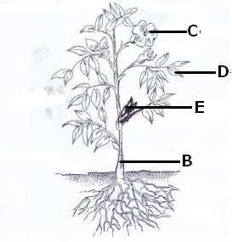47. The diagram below is of a plant. Use it to answer the questions that follow.

(a) Of what importance is part C to a plant?
(b) Name the parts lebelled B and E.
(c) Apart from photosynthesis, give any other process that takes place in part D.
48(a) Kagolo earns money from charcoal burning. In which two ways is this activity bad to the environment?
(b) Suggest two ways charcoal use can be reduced.
49. The data shows information collected from two homes of Kato and Wasswa.

Kato’s Home | Wasswa’s Home
1. Has a latrine. | 1. Use bush for defecation.
2. Has a plate rack. | 2. Has a place rack.
3. Boils water for drinking. | 3.Boils water for drinking.
4. Has a clean and well maintained compound. | 4. Has a dirty and bushy compound.

(a) Which of the homes is likely to have health problems?
(b) Identify the two things likely to affect health in the home named in (a) above.
(c) Mention one disease likely to affect people living in the home you have named in (a) above.
50(a) Under what condition may a magnet lose its magnetism?
(b) Give two ways how magnets are important in our everyday life.
51(a) State two factors that can lead one to smoke.
(b) Give one poisonous substance found in tobacco smoke.
(c) Name the crop from which cigarettes are made.
52(a) What is mechanical advantage in relation to machines?
(b) Under what group of machines is a nut cracker?
(c) Name one force that affects the efficiency of a machine.
(d) Draw a wedge in the space provided below.

53 Match the organs with their functions.
(i) kidney produces insulin
(ii) liver stores information
(iii) brain filters harmful products from blood
(iv) pancreas produces heat in the body

54. Use the diagram of an egg given below to answer the questions that follows.
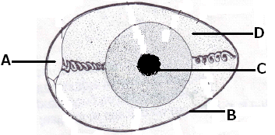

(a) Name the part marked C.
(b) Give the functions of parts A and D.
(c) Why is part B porous?
55(a) Identify two natural sources of light.
(b) How is light useful to plants?
(c) Why can’t people see around corners?

END

ITEM NINE
SECTION A (40 MARKS)
- Which main body part of an insect has breathing organs?
2. Name the blood vessel which takes blood to the kidney.
- Name the energy resource obtained from the sun.
4. Mention any one factor that affects condensation.
5. State the difference between pitch and volume of sound?
The diagram below shows a simple machine used to drill holes in wood. Use it to answer questions 6 and 7.
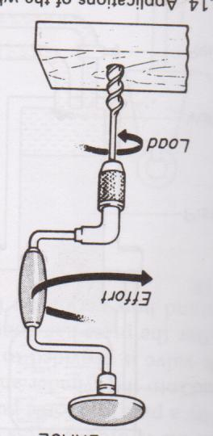

Wood

6. To which class of levers does the machine above belong?
7. Use an arrow and letter X to show the load.
8. State any one way of reducing moisture in a poultry house.
- Mention one reason why some flowers produce scent.
11. State the difference between the feeding of a female anopheles mosquito and a housefly.
12. Give any one way in which boiled drinking water can get contaminated.
13. Name the biggest sense organ of man’s body.
14. Give any one way of making an electro-magnet stronger.
15. State any one way in which parents can prevent scurvy from affecting the children.
16. Give any one way in which some plants are adapted to dry conditions.
17. Mention any one result of not using birth control methods by married people.
18. Why is a crocodile able to live in water and on land?
19. Give the use of a lactometer to a cattle farmer.
20. Give one reason why young children should be given food rich in proteins.
The diagram below shows parts of a joint. Study and use it to answer question 21 and 22.
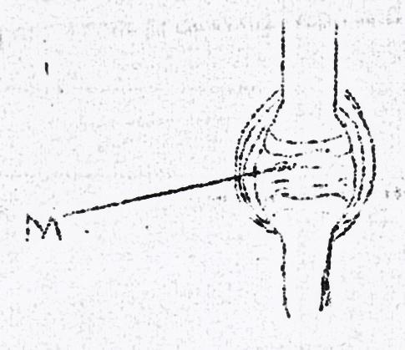

21. Name the part marked with letter M.
22. Using letter N, show the tibia on the above diagram.

23. State any one method of controlling moisture loss from soil.
24. Why do health workers advise us to keep the grass near our homes short?
25. How does water in the body help to make digestion of food easy?
26. How is a telescope different from a microscope in terms of function?
27. By what means do ferns reproduce?
28. Apart from swallowing poison into the digestive system, state another way germs can get into the body.
29. Why are bees able to carry pollen grains from one flower to another?
30. Give an example of a carnivorous mammal which is a scavenger.
31. Name the human body system which moves the body.
32. In the space below, draw a kitchen utensil rack common in homes.

33. State one disadvantage of depending on wood fuel as an energy source in a home.
34. Name the insect pest for maize common in maize gardens.
35. Apart from providing heat and light, give another use of electricity in a home.
The diagram below shows a musical instrument. Study and use it to answer questions 36 and 37.
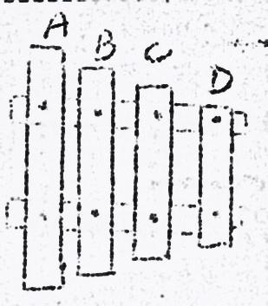

36. Which of the wooden bars marked A, B, C, D produces sound of the lowest pitch?
37. Give a reason for your answer in 36 above.
38. State the importance of bacteria in food chain.
39. Name the virus that causes AIDS.
40. State one reason why farmers stake banana plants.

SECTION B
41. a) Give any two materials from which organic fertilizers are
obtained
b) State any two bad effects of artificial fertilizers on soil
42. a) Give one reason why the sick and the elderly are grouped as
vulnerable
b) Apart from the sick and the elderly, mention any other two
groups of vulnerable people.
c) Mention one reason why vulnerable people need special feeding.
43. The diagram below shows a plant. Study and use it to answer the questions that follow.
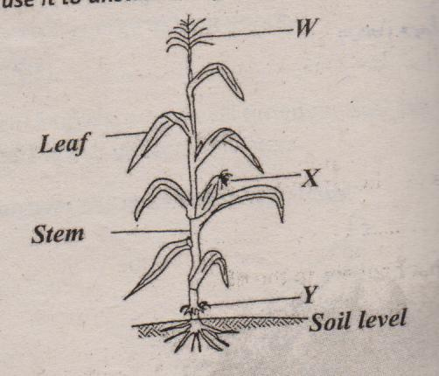

a) To which group of plants does the above plant belong?
b) What type of root system does the plant have?
c) State the importance of part labeled W to the plant.
d) Name the part marked Y.
44. a) Name the two parts that a skull is composed of.
b) Which one of the parts named above protects the brain?
c) State one way of keeping the skull strong.
45. a) State the role of each type of bees below in a hive.
i) drone bee __________
ii) worker bee _______________
b) Name the material used by bees to seal small cracks and gaps in the hive.
c) Give the importance of keeping bees.
46. The table below shows diseases the vectors that spread them and the disease causing germ. Study and complete it correctly.
Disease | Vector | Germ
Malaria | Female anopheles mosquito | ……………….
Sleeping sickness | ………………………………… | protozoa
………………………….. | Rat fleas | bacteria
Trachoma | houseflies | ………………...

47. a) State the importance of the sun to life of plants.
b) Name the part of a plant which makes food for the plant.
c) Write the term used to mean plant response to light.
d) State one reason why mushrooms cannot make their own food.
48. The diagram below shows a method of cooking food. Study and use it to answer the questions that follow.
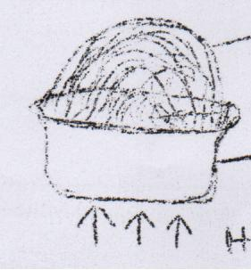
banana leaves

saucepan

Heat

a) Name the material from which the saucepan was made.
b) State the use of banana leaves in the process shown above.
c) Give any two factors which can affect the amount of heat from
the source shown above.
49. The table below shows parts of a rabbit in A and that of a fish in B.
A (rabbit) | B (fish)
Ear  Fur  Lungs  Foot | Fins  Gills  Nostrils  Scales

For each of the parts of a rabbit, write the part of a fish (from B) which performs a similar function.
- Ear ___
- fur ___
- lungs _
- foot _______
50. a) Write in full S.T.I
b) Give any two bacterial diseases that people get through
unprotected sex with an infected person.
c) Suggest one sure way a P7 child can avoid contracting STIs.
51. a) What is passive smoking?
b) Give one reason why active smokers find it hard to leave
smoking.
c) State any two effects of smoking to the family of a smoker.
52. a) Where does urine come from to enter the urinary bladder?
b) Why are we advised not to hold urine in the bladder for long?
c) Name the acid present in urine.
d) Name the path of urine out of the human body.

53. The diagram below shows a weather instrument. Study and use it to answer the questions that follow.
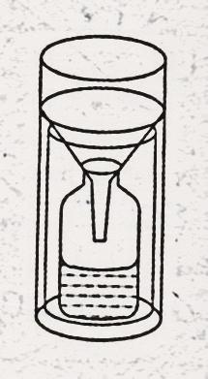
30cm

a) Name the weather instrument shown in the diagram above.
b) What is the use of the instrument above at a weather station?
c) Give one reason why the above instrument should be put in an open place
- Name the element of weather which influence the way people
dress.
54. a) To which group of mammals do bats belong?
b) Name the type of bats that feed on blood from other animals.
c) State any two ways in which sound waves and echoes are important to bats
55. a) Apart from predators, mention any two poultry pests.
b) State any two ways of keeping predators out of a poultry house.

END

ITEM TEN
SECTION A:
1. Mention any one type of chicken reared in your community.
2. State one characteristic that is common to both mammals and birds.
3. Give any one reason why people keep cattle.
4. State one reason why pregnant women should go for antenatal care.
5. The diagram below is of a signpost. How is the message on the post useful to a P.7 pupil?
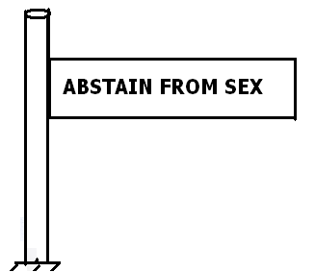

6. Why is humus a very important component of soil?
7. State one example of a spore bearing plant.
The diagram shows electric wires on poles. Use it to answer question 8.
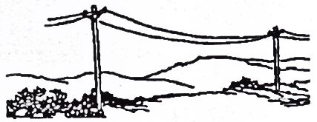

8. Basing on the appearance of the wires, what was the weather of the atmosphere?
9. Why are the wires left sagging during installation?
10. Write down any one component of air.
11. Outline any one cause of dehydration to babies.
12. Give a reason why drinking water should be boiled.
The diagram below shows part of a plant. Use it to answer questions 13 and 14.
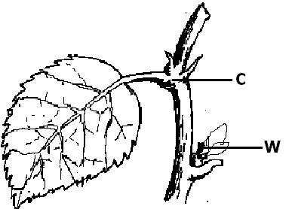

13. Name part marked C.
14. How is part marked W important?
15. Mention any one way of saving energy in our environment.
16. State one effect of smoking by a pregnant woman.
17. How is the Eustachian tube important to the ear?
18. Why are mango crops regarded as perennial crops?
19. How are the kidneys important in the body?
20. State one vector borne disease.
21. By what process does water change into ice?
22. Why was a toilet made in a way that after flushing water remains under the bowl?
23. Which body organ helps a P.6 girl to identify the best perfume to wear?
24. State any one anti-social behaviour at school.
25. Why is rusting of metals regarded as a chemical change?
26. State one fuel commonly used at home.
27. How can tapeworm infestation be controlled in our communities?
28. By what process does dust spread in the air after sweeping?
29. State the living organism necessary for the production of butter from milk.
30. Give one example of an ecto-parasite in goats.
31. State any one petroleum product.
Use the diagram below to answer questions 32 and 33.
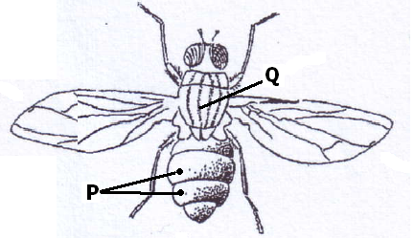

32. Name part marked Q.
33. How is part marked P useful to the insect?
34. Write HIV in full.
35. Why is it important to recycle polythene wastes?
36. Mention one way of controlling mosquitoes while at the larva stage.
37. Why is Tuberculosis immunised at birth?
38. Mention the term used to describe the drugs used to treat common disease in a community.
39. State one way the appearance of arteries is different from that of veins.
40. How does afforestation conserve the environment?

Section B
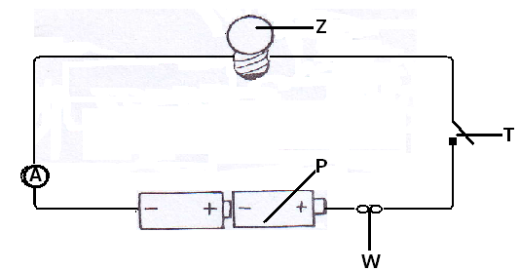41. The diagram below shows a electric circuit. Use it to answer the question about it.

(a) Name part marked W.
(b) How is part marked T useful to the circuit?
(c) State one energy change that takes place at Z when the switch is closed.
(d) Calculate the amount of voltage that was used in the circuit.
42(a) Write down the method used to make alcohol of a high concentration.
(b) Give one reason why people take alcohol.
(c) State one danger of alcohol to an individual.
(d) Mention the low that forbids a P.7 child from taking alcohol.
43(a) How are the following bees important in a hive?
(i) worker bees
(ii) queen bee
(b) Why is it that there are always very few drone bees in a hive?
(c) How can man benefit from the presence of bees in the environment?
44(a) What is personal hygiene?
(b) State two activities that can be carried out to promote personal hygiene.
(c) Single out any one item you can use to maintain your personal hygiene.
45(a) What is a skeleton?
(b) State two ways in which a skeleton is useful to the body.
(c) Mention any disease that can affect the skeletal system.
46. The diagram below shows an experiment that was carried out in a science lesson. Use it to answer the questions that follow.
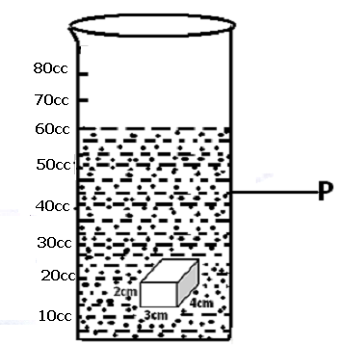

(a) What method was used to find the volume of the cuboid?
(b) Name container marked P.
(c) At what level will water be when the cuboid is removed from the water in the experiment? (2 marks)
47(a) How is rain formation important in the environment?
(b) State any one process that is involved in the rain cycle.
(c) Name the clouds that are responsible for giving us rain.
(d) Besides giving us rain, how else are such clouds mentioned in (C) above useful to man?
48(a) Define the following terms.
(i) Transplanting
(ii) Pruning
(b) State the tool used during transplanting.
(c) Give one reason why farmers mulch their gardens.
49(a) What is photosynthesis?
(b) State any one condition necessary for photosynthesis to take place.
(c) By looking at a plant, how can you tell that the plant is monocotyledonous one?
(d) Name one plant that stores its food in the leaves.
50. The diagram below shows feet of different birds. Use it to answer the questions that follow.
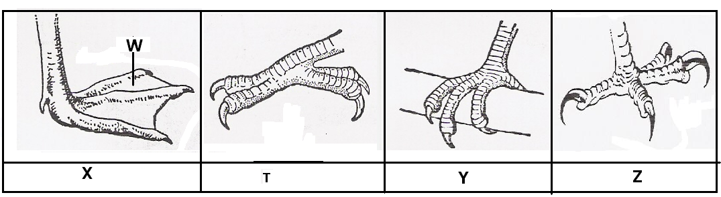

(a) Name part marked W on the foot marked X..
(b) What does the bird with foot marked Z fed on?
(c) Identify the group of birds with foot marked T.
(d) State one group of a bird with foot marked Y.
51(a) Name two enzymes produced by the pancreas.
(b) How are the enzymes important in the body?
(c) State any one characteristic of enzymes.
52. The diagram below shows three different types of teeth. Use it to answer the questions that follow.
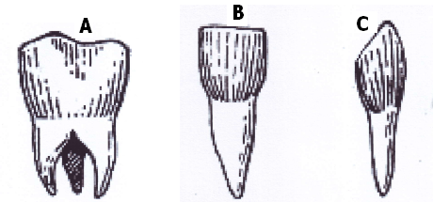

(a) Name the tooth marked A.
(b) State the function of tooth marked C.
(c) How is tooth marked B adapted to its function?
(d) How many teeth should a normal adult person have?
53(a) What is food security?
(b) State two causes of food insecurity.
(c) Mention one way you can ensure food security.
54(a) Mention one handling structure on a livestock farm.
(b) How is the structure mentioned in (a) above useful to the livestock farmer?
(c) Mention one type of fence used in cattle management.
(d) Give one reason why it is important to fence off livestock animals.
55(a) What is a foreign body?
(b) State the first aid you can give to a person who has a foreign body in the following body parts.
(i) eyes
(ii) throat
(c) Why is it important to give first aid?

END

ITEM ELEVEN
SECTION A: 40 MARKS
(Questions 1 to 40 carry one mark each)
1. Name one domestic animal used for protection in a home.
2. What type of farming should a farmer use in order to harvest both crops and wood? ₍₂₀₀₉₎
3. State one natural cause of a family failing to have enough food.
4. Give one reason why a tsefsefly is dangerous to cattle.
5. Name the kind of energy possessed by water at 100⁰C. ₍
6. Why does a coin sink when it’s placed in a basin full of water?
7. State one effect of heat on a metal.
8. Write down one function of joints in a human body.
9. Write down one way in which a Primary Seven pupil can help in the control of cholera in a community.
10. Arrange the following organisms in the correct order of a food chain. caterpillar dog leaves birds

11. Sunbirds visit flowers to get nectar. How do plants benefit from these birds?

The diagram below is of a simple circuit. Use it to answer questions 12 and 13.
A
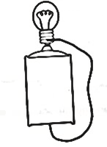

12. Draw an arrow on line P to show the direction of the flow of electricity.
13. Apart from light, which other form of energy is produced at A?
14. Give a reason why drugs should be kept away from children.
15. Name the class of simple machines to which an axe belongs.
16. State one type of accident whose First Aid is to put the affected part of the body in cold water.
17. Name any one characteristic of seeds which are dispersed by wind.
18. State the compass direction in which a freely suspended magnet will rest.
19. Name the turning point of a machine.
20. How do conifers differ from other non-flowering plants?
21. How can the pitch of a string of a musical instrument be changed?
22. Give any one way in which the human liver can be kept in proper working condition.
The diagram below is a section of a flower. Use it to answer questions 23 and 24.
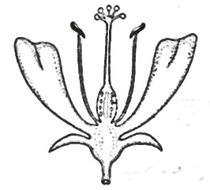

A

23. Name the part marked A.
24. Use letter P to show the part that produces the male reproductive cells.
25. State one disadvantage of keeping fingernails long.
26. Name any one mammal that lives in water.
27. Why does a farmer cut off the leaves of a banana sucker before planting it?
28. Why is it important for a husband and his wife to be treated together if they have got gonorrhoea?
- Why are electric wires left sagging loosely between poles during construction?
30. Why does a clay-made charcoal stove use less charcoal than a metallic one?
31. State one way in which a child gets natural immunity.
The diagram below is of a common animal. Use it to answer question 32.
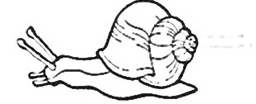

32. Which disease does the above animal spread to humans?
33. Name the part of the human eye that works like the film in a camera.
34. Give any one way in which a single fixed pulley is used in a school.
35. How does a fish benefit from its slippery body?
36. Which deficiency disease is caused by lack of Vitamin D in children’s diet?
37. Why is it advisable to leave the pit of a VIP latrine open?
38. Name the cattle disease whose sign is a swollen and painful udder.
39. Which structures enable the trachea to remain open all the time?
The diagram below is of a mosquito larva. Use it to answer question 40.
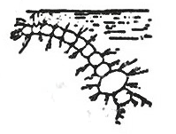
40. What disease does the mosquito which develops from the above larva spread?
SECTION B
(Questions in this section carry four marks each)
41(a) Which bone joins the pelvis and the tibia?
(b) Apart from movement, give any other two functions of the human skeleton.
(c) What is the function of tendons in a human body?
42. The table below shows food stuffs prepared in different families.
Study it and answer the questions that follow
Family A | Family B | Family C | Family D
matooke  yams  meat  beans | cassava  beans  posho  yams | potatoes  posho  cassava  yams | millet  fish  goat milk  mangoes

(a) Which family will be able to have vitamin C?
(b) Which family has proteins but lacks fats?
(c) What food nutrients are lacking in family A?
(d) Which family has almost a balanced diet?
43. Give any four ways in which plants depend on each other.
44. The diagram below shows a rabbit house. Use it to answer questions that follow.
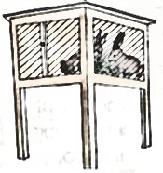

(a) Give any one reason why the rabbit house is raised above the ground.
(b) Give any two reasons why wire mesh is used in building a rabbit house.
(c) State any one thing that should be provided to the rabbit in the house.
45(a) Give any two characteristics that are common to a frog and a crocodile apart from being vertebrates.
(b) How is fertilization of a frog different from that of a crocodile?
(c) Name any one other vertebrate that can be classified with a frog.
46(a) Suggest two reasons why Young Farmer’s clubs are important in schools.
(b) Give any two activities that can be done by Young Farmer’s clubs in schools.
47. Equal amounts of water were poured onto soil A and B shown in the diagram below.
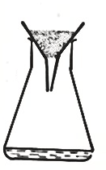
Study carefully the diagram and answer questions that follow.
A B
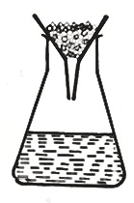

(a) From which soil did more water drop?
(b) State why more water dropped from the soil you have named in (a) above.
(c) Name the type of soil in B.
(d) Give one use of the type of soil in A.
48(a) What name is given to the process that turns sugar to alcohol?
(b) Apart from making alcohol, state two other ways the process you have named in (a) can be useful to human beings.
(c) Name the fungus used in this process.
49(a) Which organ removes urine from the body?
(b) To which body system does the organ that removes urine from the body belong?
(c) Where does urine collect before it is removed from the body?
(d) Name one substance found in urine.
The diagram below shows a method of making a magnet.
Study it and use it to answer question 50.
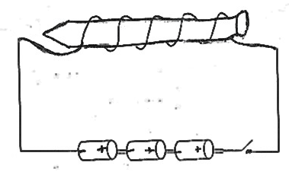
A

50(a) Name the method of making a magnet shown in the diagram.
(b) What pole will the part marked A become?
(c) What would you do to the dry cells in order to increase the strength of the magnet?
(d) Apart from the method shown in the diagram, name any other method of making a magnet.
51(a) Mention two primary sex changes that happen in boys.
(b) Give two secondary sex changes which happen in both boys and girls.
52(a) Name the two types of pollination in flowering plants.
(b) Write any two agents of pollination.

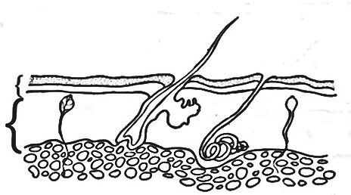
The diagram below is of a human skin. Use it to answer question 53.

A Z

B

Y
53(a) Name the layers A and B.
(b) Give the function of the parts labelled Y and Z.
54. Match the diseases in list A with the signs and symptoms in list B.
A B
Polio Swollen neck
Measles Stiffness of muscle
Tetanus Paralysed tissues
Diptheria Skin rash
(a) Polio ______________
(b) Measles _____________
(c) Tetanus ______________
(d) Diptheria _____________
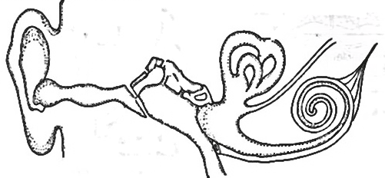
55. Study the diagram of the human ear below and use it to answer the questions that follow.
M P

N

(a) Name the parts marked M and N.
(i) M _________
(ii) N ____
(b) Give the function of the part marked P
(c) Use letter B to show the part of the ear responsible for balancing the body.

END

ITEM TWELVE
SECTION A
- Besides claws, name any one other weapon used by animals for defence.
- State any one way a slug is similar to a grass hopper.
- Why is it necessary to groom finger nails?
- What first aid can you give to someone with a broken humerus?
- Apart from keeping water in the soil, in which other way is mulching important to a farmer?
- Common salt gives flavor to food, give one other use of salt in the body.
- Using an arrow indicate the direction of flow of electricity in the diagram.
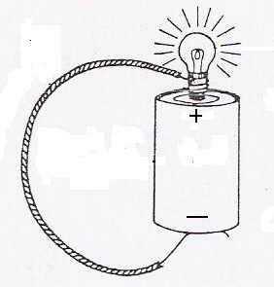
- Why does smoke from a burning heap of grass move upwards?
- State one method you would use to control insect pests.
- Give one breed of rabbits.
- Why is water not good for putting out petrol fire?
- Why is a wheelbarrow classified as a second class lever?
- Give one useful piece of information that should be considered before taking any drug.
- Name any one raw material needed by green plants to make food.
- What is dairy farming?
- Identify one root crop which is propagated by planting seeds.
- Why does a potted plant grow towards the window?
- Give one way of preventing constipation in children.
- State one natural disaster common in mountainous areas.
- Why are electric wires left sagging loosely between poles during construction?
- Why do maize plants develop prop roots at maturity?
- How is humus formed?
- The diagram below shows a common garden tool. What is the use of this tool to a farmer?
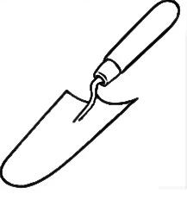

- How does draining stagnant water control the spread of malaria?
- Why does a car tyre wear out quickly from a tarmac road than on a murram road?
- State the role of the eye as a sense organ in the body.
- How is sisal important as a resource?
- How do coniferous plants reproduce?
- Of what importance are ventilators on a house?
- Why can’t mushrooms make their own food?
- State any one condition for rusting to take place.
- Give any one sustainable way of using resources in the environment.
- Name any one crop which is first grown as seedlings in a nursery bed.
- Give any one common sign of a common cold.
- Name the only flying mammal in the environment.
- Where does fertilization take place in human beings?
- How important is an embryo in a viable seed?
- State any one habit that keeps your body clean.
- Write any one material that dissolves in water.
- Name the first stage in a village food path.
SECTION B.
- (a) Name any two insects that sting their enemies.
(b) Why do the above named insects sting their enemies?
(c) State one difference between a scorpion and a preying mantis.
- (a) What is thinning?
(b) Give any two advantages of thinning.
(c) Why are the leaves of a plant considered to be the most important past?
- 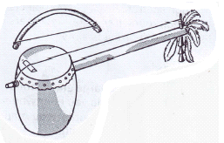The diagram below is a musical instrument. Study it and answer question 43.
peg
string

- To which group of musical instruments does the above belong?
- How does it produce sound?
- What can be done to change the pitch of the above instrument?
- Give any one way of storing the sound produced by the above instrument.
- (a) Name any two respiratory organs.
(b) How are the air sacs able to perform their function of gaseous
exchange?
(c) Where in the human body does internal respiration take place ?
- (a) Give any two properties of pure water.
(b) Why is distilled water not recommended for drinking?
(c) Name one method used to produce clean water from dirty water.
- (a) What is a human skeleton?
(b) In which way are muscles useful to the muscular skeletal system?
(c) Give any two ways of caring for the muscular skeletal system.
- In four short sentences, describe how you would separate a mixture of salt, sand and iron filings.
- (a) What is a balanced diet?
(b) Give any two major components of a balanced diet.
(c) Give any one importance of water to the human body.
- Below is a list of different groups of simple machines.
- How are they applied in our daily life?
- Pulleys
- Wedges
- Wheel and axles.
- Why is it easier to drop a load from a lorry than lifting it back to the lorry?
- (a) Write PHC in full.
(b) Which element of PHC helps in the control of the following;
(i) Rapid population growth
(ii) Drug abuse and addiction
(c) State any one principle of PHC.
- (a) Why do builders construct houses with a damp proof course?
(b) How dangerous is it to have a latrine near a water source?
- Give the use of the following components of a residential house.
- Windows
- Ventilators
- Match the items in list A with those in B.
A B
Oviduct absorption
ileum diffusion
Cortex fertilization
alvaeoli filtration
- Oviduct ______
- Strip cup ________
- Cortex ______
- Alveoli ___
- (a) What is mulching?
(b) Name any one material used for mulching.
(c) Write down one advantage and disadvantage of mulching.
(i) Advantage
(ii) Disadvantage
- (a) What protozoa causes malaria?
(b) Where do female mosquitoes lay their eggs?
(c) Give any two ways of controlling the spread of malaria fever.

- The diagram below shows three rays of light on a mirror.
O
C
A
B
35⁰
p

- What kind of reflection is shown above?
- Name ray BO.
- Put an arrow head correctly on ray CO.
- What is the size of angle P in degrees?

END

ITEM THIRTEEN
SECTION A
- Name the part of the human body which protects the brain.
- Why should granaries be kept dry?
- How are leguminous crops useful in a crop rotation cycle?
- In which one way can the sun be useful in germ control?
- Why do birds need beaks?
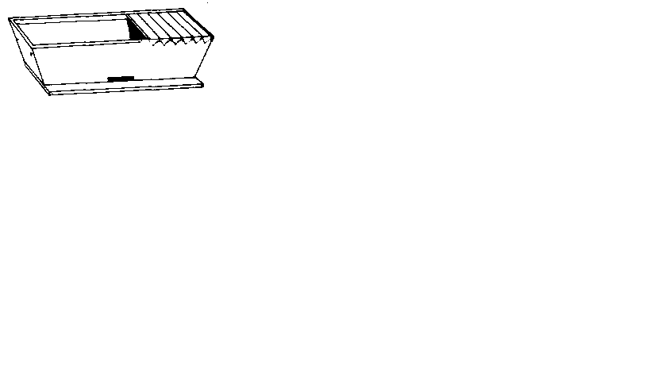
The diagram below shows a beehive. Use it to answer question 6 and 7.

- Identify the type of bee hive shown above.
- Give one advantage of using the above hive.
- Give the importance of correct body posture to humans.
- Why is rinsing necessary when washing clothes?
- Besides getting manure, how else do farmers benefit from cow dung and urine?
- Write any one unit used when buying food stuffs for home use.
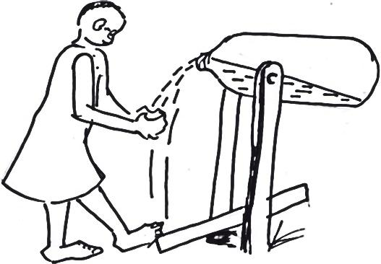
The diagram below shows a locally made tool for washing hands. Use it to answer questions 12 and 13.

- Identify the sanitary tool shown above.
- By use of letter M, show the effort.
- Give any one advantage of row planting in crop growing.
- Which method of preparing hides involves the use of the sun’s energy?
- Write one danger of drying wet wood/timber under sunshine.
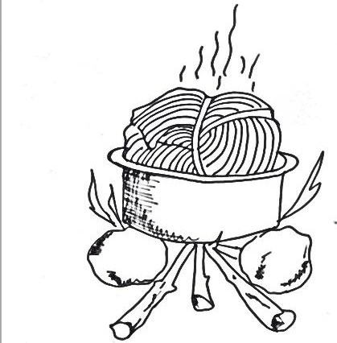
The diagram below shows food being prepared. Use it to answer question 17 and 18

- Give the importance of covering the food with banana leaves as shown above.
- In which one way are algae similar to pine?
- Name any one fungus we eat.
- How does smoking help to preserve meat?
- Which component of the environment helps to increase oxygen into the atmosphere?
- How does paint prevent rusting in metals?
- Give one way in which water promotes personal hygiene?
- How can you stop small fire in a school building?
- Why is a ship able to float on water?
- Name the second stage in the life cycle of a butterfly.
- Why is it not good to rub the eyes when an object drops on them?
- Name any one human disease that can spread when a sick person coughs or sneezes without covering his/her mouth.
- How does a fuse work?
- Why are magnets unable to attract pieces of wood?
- In the space below, draw the shape of a dairy cow.

- Name one mineral energy resource.
- Why is flowering of plants grouped under biological changes?
- Give any one advantage of rotational grazing in cattle management .
- Why is poor disposal of broken bottles dangerous to humans?
- How do trees help in rain formation?
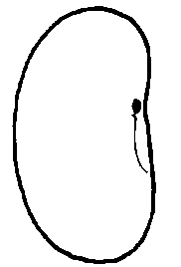
The diagram below shows a soya bean seed. Use it to answer question 37 and 38.

M
N

- Name part labeled M.
- How is part N useful to the seed?
- Why is sub soil not good for crop growing?
- Give the use of a shade on a nursery bed.
SECTION B
- (a) Name any one crop pest that attacks maize grains in store.
(b) Write one danger of storage pests to crop farmers?
(c) Give any two ways storage pests can be controlled.
- Match the animals in A to their habitats in B correctly.
A B
(i) white ants web
(ii) spider byre
(iii)goat ant hill
(iv)cow pen

- White ants
- Spider
- Goat
- Cow
- (a) What are convulsions?
(b) Give the cause of convulsion.
(c) Give the first aid for convulsions.
(d) Flow can convulsions be controlled?
- (a) Besides running water, name one other agent of seed dispersal.
(b) Outline two characteristics of seeds dispersed by running water.
(c) Name any one plant dispersed by running water.
- Study the table below and complete it.
Vaccine | When given | Site of immunisation
Measles vaccine | 6, 10 & 14 weeks | ……………………………………………
BCG vaccine | ……………………………………………. | Right upper arm
…………………………………… | Birth | mouth

- The diagram below shows a source of electricity use it to answer question 46
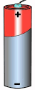

- Name the source of electricity shown above.
- By use of letter N, show the negative terminal.
- State the energy change that takes place in the above source of electricity.
- Write one disadvantage of using the above source of electricity.
- (a) Give any two natural causes of changes in the environment.
(b) Write two activities that a child can do to prevent drought.
- (a) Give any two enemies of bees.
(b) How do people protect their hives from bee enemies?
- (a) What is excretion ?
(b) Mention any two examples of excretory organs.
(c) How do we care for our excretory organs?

- The diagram below shows the human foot. Use it to answer question.
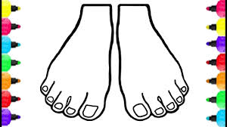
K

- Identify the part marked K.
- Name one tool used in shortening structure K.
- Write one fungal disease that affects the human foot.
- How do you care for the above body part?

- The diagram below shows a model of the human arm. Use it to answer questions that follow.
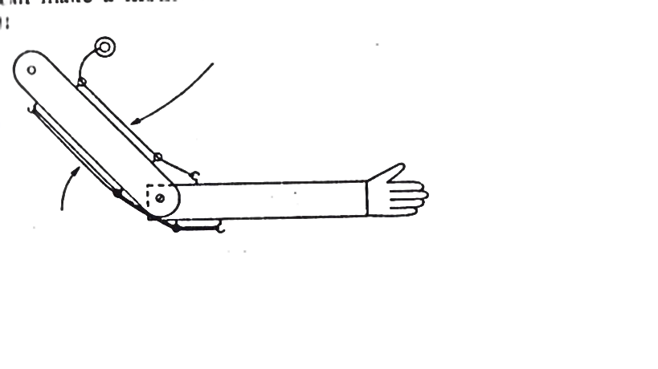
Rubber
cord

- What do the following parts represent in our bodies;
- Cord
- Rubber
- Name any one bone found in part x.
- By use of letter S, show the position of the hinge joint.
- (a) Why do animals need homes?
(b) How are wild animals kept in a game reserve cared for by people?
- (a) Name any two groups of simple machines.
(b) How can you improve on the proper functioning of simple machines?
- The diagram below shows a rabbit. Use it to answer questions that follow.
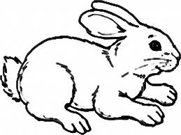
M
K
N
R

- Name the part labeled R and K.
- How is the function of part K different from that of N?
- How do we care for the above animal?
- (a) Name any two intestinal worms in humans.
(b) Write any one sign of worm infestation in humans.
(c) How can you prevent yourself from intestinal worms?
END

ITEM FOURTEEN
SECTION A.
- Mention one condition plants need to make starch.
- Why are telephone wires left loose between poles.
- What is the importance of family planning in a family?
- Give one breed of chicken.
- How does a drum produce sound when hit?
- How are sweets dangerous to our teeth?
- In which state of matter is water at 109⁰C?
- Name the type of tooth shown in the diagram below.
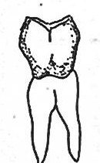

- Name the intestinal diarrhoeal disease caused by amoeba.
- What is the importance of ossicles in the ear?
- Why is heat necessary in a broader?
- What are pathogens?
- Apart from silent heat, name another type of heat in cattle keeping.
- Which polio vaccine is administered to babies at birth?
- Give one natural process in plants which uses oxygen.
- How do amphibians like frogs help in controlling malaria ?
- Write HIV in full.
- The diagram below shows roots of some plants. Name the roots marked Q.
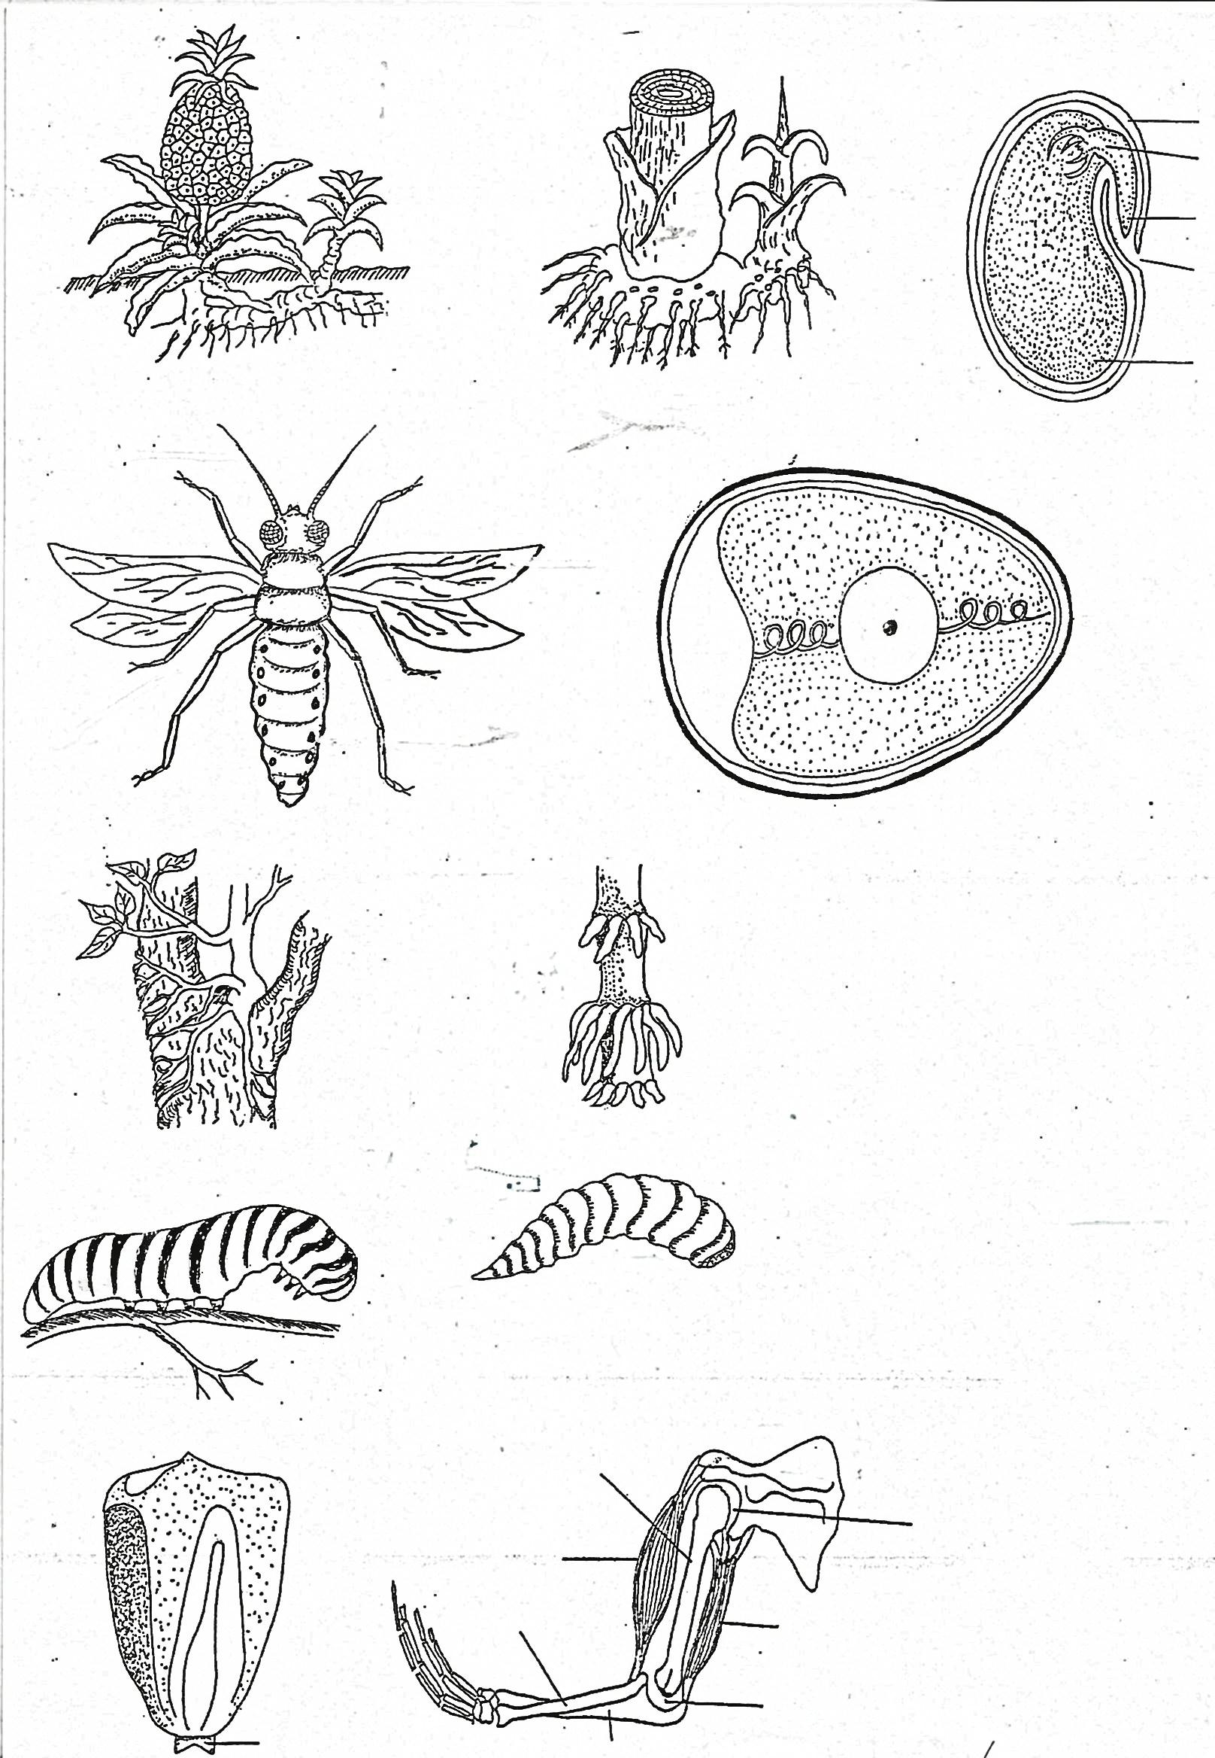
Q

- Why don’t fraternal twins look alike in most cases?
- Name the smallest unit of a living thing.
- How can filtered water be made safe for drinking?
- What is the use of a sickle to a farmer?
- Which digestive disorder does one get due to lack of roughages in the diet?
- Apart from the mode of spread, give any other similarity between trachoma and cholera.
- Why are people suffering from severe vomiting given plenty of fluid to drink?
- Besides fish, name any one animal that can be kept in an aquarium.
- How are conifers different from ferns?
- What advice would you give to a rabbit farmer whose rabbits are suffering from intestinal worms?
- State one way of managing accidents.
- Which vector spreads zika germs?
- Farrowing is the act of giving birth to a litter in swine. Name the smallest young one in a litter.
- Why isn’t an earthworm reguarded as a soil component?
- Which type of immunity does a man of 30 years gets after recovering from sickness without using any drug?
- Name the valve of the left part of the heart that separates the atrium from ventricle.
The diagram below is a bottle of syrup a mother bought from a pharmacy. Use it to answer questions 35 and 36.

Physician’s writings
Syrup
2 x 3
30 min
Before eating

- What do we call the physian’s writings on the bottle above?
- Point out any one danger that one might face if he/she does not follow physicians writings.
- What are arthropods?
- Why is the eye said to be a sense organ?
- What happens to pollen grains when they are deposited on the stigma?
- Name any one example of primary colours of light.
SECTION B
- Below are diagrams of blood vessels. Use them to answer the following questions.
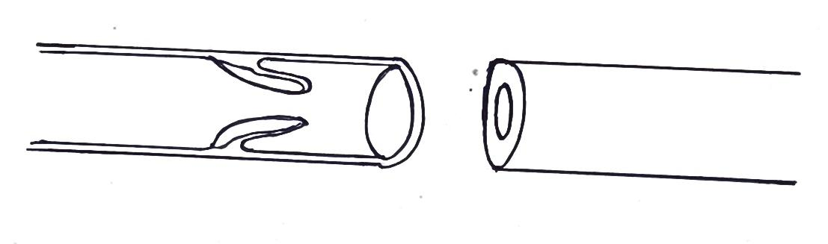
Y
Z

- Name the type of blood vessels Y and Z
- Give one functional difference between blood vessel Y and Z.
- To which body system do blood vessels above belong?
- (a) What is PHC?
(b) State any two elements of PHC where a P.7 pupil can fully
participate.
(c) Give one role of VHT in a community.
- (a) Write any two components of soil.
(b) State two processes in which soil is formed.

- The table below shows the development time for types of bees in a beehive. Use it to answer the questions that follow.
Stage | Worker | Queen | Drone
Hatching | 3 days | 3 days | 3 days
Cell covering | 8 days | 8 days | 10 days
Turns into pupa | 11 days | 10 days | 14 days
Becomes an adult | 20 days | 15 days | 22 days
Comes out of the cell | 21 days | 16 days | - ays

- What event takes place at the same time to all the three types of bees in the hive?
- Which type of bee matures fastest?
- At what stage in the life cycle are bees on the 5th day?
- After how many days will the worker bee be able to fly?
- Match the following lists correctly.
A B
Biological change digestion
Atmospheric change formation of clouds
Chemical change ecdysis
Physical change sublimation
- Biological change ______
- Atmospheric change ______
- Chemical change __
- Physical change ___
- (a) What type of skeleton do the following organisms posses?
- Snail _______
- Newt ____
(b) Name the example of immovable joint in the human skeleton.
(c) How is the human skeleton important to circulatory system?
- (a) What is a beam in light energy?
(b) List down two types of beams.
(c) What happens when light rays strikes on an opaque object?
- (a) Three liquids paraffin, mercury and water were put in a test tube and shaken. Then they were allowed to settle as shown below.
B
A
C
Test tube

- Name the liquid marked B and C.
- Why does liquid A settle on top?
- Why does liquid C behave like that in the diagram above?
- Bamwiine weighs 60kgs and sits 6 metres away from the pivot on a see-saw. How heavy should Atamba who is sitting 4 metres away from the pivot be in order to balance the see-saw.
- (a) What are resources?
(b) Name two non-living resources.
(c) Give one type of resource in the environment.
- (a) Name the best food for babies.
(b) Why is it not advised for the mothers with breast cancer to breast
feed their newly born babies?
(c) State the malnutritional disease that develops due to lack of the following food values in the diet:
(i)Proteins _______________
(ii)Carbohydrates _________

- (a) Complete the food chain using arrows
Bacteria fowl locust plant leaves
Fowl locust plant leaves
(b) Identify the following organisms from the above food chain
(i) Producer ________
(ii) secondary consumer _____
(c) Name the source of energy for the plant leaves to make their food.
- (a) Name any one type of latrine.
(b) How far should a pit latrine be from a water source?
(c) Give the function of a screen on a VIP latrine.
- Point out the type of latrine commonly used in rural areas of Uganda.
- (a) What is germination?
(b) Name one type of germination.
(c) What condition of germination is got from the sun?
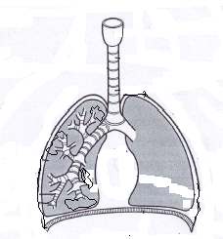(d) How is oxygen useful during germination?
X
W
Y
- The diagram below is the respiratory system.

Y

- Name the parts marked Y and X.
- Why is part W made up of rings of cartilage?
- How is part X adopted to its functioning?

END
ITEM FIFTEEN
SECTION A (40 MARKS)
- Name any one cause of soil erosion.
- State one way of controlling endo parasites in cattle.
- Give any one human activity that can result into environmental degradation.
- Which immunisable disease causes stiffness of muscles?
- How does a mushroom differ from a conifer as far as feeding is concerned?
- Name any one device that changes mechanical energy into electric energy.

The diagram below shows a freely suspended magnet. Use it to answer the questions 7 and 8.
P
Q

- Name the pole of the above magnet marked with letter Q.
- How is the property of magnet shown above useful to pilots?

- The diagram below is of an electric bulb. Give a reason why part A is coiled.
A

- Name the plant process that helps in cooling the plants.
- How is water useful to a germinating bean seed?
- Name any one mineral deficiency disease.
- State one of maintaining proper functioning of the heart.
- Which type of change maintains the properties of the original substance?
- In which chamber of a modern bee hive does a queen bee lay its eggs?
- Why does a child suffering from tape worms become malnourished?
- In which way does the cutting of finger nails short control the spread of diarrheal diseases?
- How does the use of a charcoal saving stoves help to conserve the environment ?
- Name one living natural source of light.
- The diagram below shows a lever system used to raise a load. On which part of the lever marked C and P would one use more effort to lift the load.
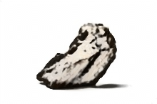
load
P
C
A

- Why is water not good for putting out fire caused by Petrol?
- Name the type of energy possessed by a bird resting on a branch of a tree.
- How does the practice of crop rotation control pests in the garden?
- Name the mineral salt that helps in the formation of blood.
- Which habit in pregnant women leads to produce under weight babies?
- Write any one way in which seeds are useful to people.
- Which sexual transmitted disease can cause blindness in young babies ?
- Identify the form of energy that can pass through wood without destroying it.
- Musa’s child was found to be dehydrated. Mention any one possible cause of dehydration.
- Mention any one disorder of digestive system.
- How does smoke move from fire move through the chimney?
- What is the use of a switch in an electric circuit?
- How is a scald different from a burn as used in accidents and first aid?
- What scientific term do we give to the degree of coldness or hotness of a place or an object?
- Give one reason why movement is essential to living things.
- How is demography important to the government?
- Identify one component of the living environment.
- What is the importance of a strip cup on livestock farm?
- Mention any one way school children can control dumping of rubbish in the school compound.
- State the component of air used by plants to make plant proteins.
SECTI0ON B.
- (a) Name any one practice that promotes oral health.
(b) State any one adaptation of the molar teeth for their function during digestion.
(c) Which region of a tooth appears above the gum?
(d) Give any one disease of the teeth.
- Kato weighs 72kgs and sits 6m away from the fulcrum on a seesaw. His sister Nyangoma who weighs 36kg sits on the opposite side of the seesaw and they balance.
- Draw a sketch to show the positions of Kato and his sister Nyangoma on the see saw.

- How far is Nyangoma from Kato?
- Match the insects in group A with their respective larva in group B.
A B
Butterfly grub
Bees Nymph
Mosquito caterpillar
Cockroach wriggler.
- Butterfly …………………
- Bees .
- Mosquito …
- Cockroach …………
- In which way are the following parts important in the human muscular skeleton system?
- Ligament …………
- Cartilage …………
(b) Name any two long bones found in the human leg.
- The diagram below shows one of the optical instruments. Use it to answer the questions that follow.
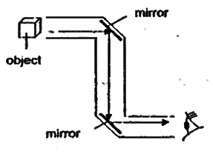

- Name the above optical instrument.
- Name the type of mirrors used in the above instrument.
- State the use of the mirrors in the instrument.
- How is the above instrument useful to submarine soldiers?
- (a) Name any one enzyme found in;
- Gastric juice
- Pancreatic juice
(b) Which acid is used to kill germs taken in with food in the stomach?
(c) Name the class of food first digested in the stomach.
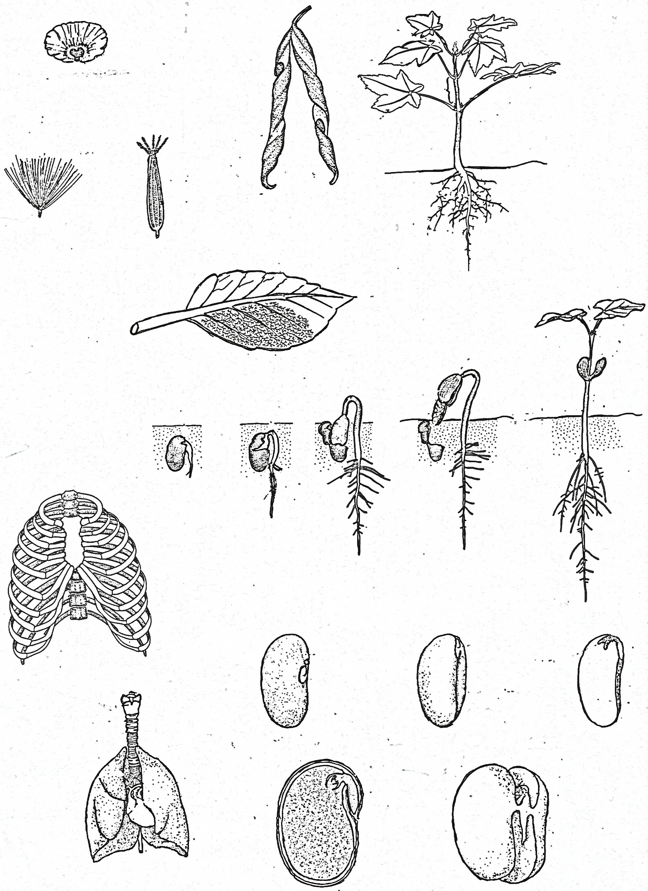
- The diagram below shows different seeds in our environment.
B

A

- State the way the above seeds are dispersed in our environment.
A…………
B ………
- State any two importance of seed dispersal to plants.
- (a) Give the meaning of the following terms as used in sound.
- Pitch …………
- Volume ……
- Noise ……
(b) How do we call musical instruments that produce sound when hit?
- (a) What is a biological change?
(b) Name any two biological changes in plants.
- How are biological changes similar to chemical changes?
- (a) What is drug Prescriptions?
(b) Give any two uses of drug prescription to a sick person.
(c) Why should drugs be kept out of reach of young children?
- (a) State any one way of making water safe for drinking.
(b) Why is distilled water not recommended for drinking?
(c) Name any one immunisable disease spread through drinking contaminated water.
- Give any one way we care for water bodies.
- (a) Name the garden tool used for the following:
- Leveling soil
- Transplanting seedlings .
(b) State any one way of controlling rusting of our garden tools.
(c) Mention any one danger of rusting on garden tools.
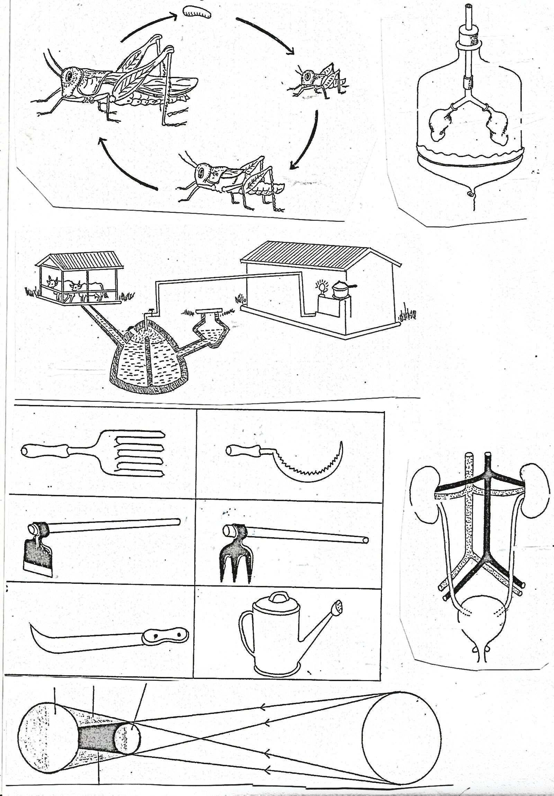
- The diagram below shows the model of breathing mechanisms of the lungs. Use it to answer the questions that follow.
B
ballon
X

- Which body system does the above diagram represent?
- What do the following parts stand for?
- B
- X
- Why is it not advisable for a person to breathe through the mouth?
- (a) What are annual crops?
(b) Mention any two examples of annual crops.
(c) How does a scare crow control birds in the gardens?
- Most diarrhoeal diseases are spread through the 4F’s, write the 4Fs in their correct order.

END

